

Baselight

User Guide (Linux)

Version 5

All rights reserved. No parts of this work may be reproduced in any form or by any means—graphic, electronic, or mechanical, including photocopying, recording, taping, or information storage and retrieval systems—without the written permission of the publisher.

Products that are referred to in this document may be either trademarks and/or registered trademarks of the respective owners. The publisher and the author make no claim to these trademarks.

While every precaution has been taken in the preparation of this document, the publisher and the author assume no responsibility for errors or omissions, or for damages resulting from the use of information contained in this document or from the use of programs and source code that may accompany it. In no event shall the publisher and the author be liable for any loss of profit or any other commercial damage caused or alleged to have been caused directly or indirectly by this document.

##### Baselight v5 User Guide (Linux)

Document Reference: FL-BL-UG-0898-v5UserGuideL Document Version: 1.8 (Linux)

Modified: 06/03/2020 14:49

© FilmLight 2020

## Contents

### About this guide xxxi

### Conventions used in this guide xxxii

### Keyboard shortcuts xxxiii

Introduction 1

### Starting the application 2

### Baselight software versions 3

### Key features 3

### Key features displayed during start-up 3

### Single-channel matte caching 3

### New AJA SDK 3

### Support for additional video monitoring devices 4

### Comprehensive media file format support 4

### Extensive metadata 4

### Automatic colour space management 4

### Full creative toolset 4

### BLG file support 4

### GPU acceleration 5

### Built-in Scopes 5

### Audio syncing 5

### Simultaneous deliverables 5

### Import and export of EDLs 5

### Works directly with FilmLight on-set systems 5

### Terminology 5

Quick Start 8

### Starting up the system 10

### Running the Baselight application 10

### Creating a new project 11

### Importing footage 12

### Browsing and adding media using FLUX Manage 12

### Using FLUX Manage to copy footage 15

### Playing back the scene 16

### Navigation controls 17

### Enabling the counter overlay 17

### Navigating using the mouse 18

### Zooming and panning with the mouse 19

### Applying basic grades 19

### Checking the colour space journey 19

### Adding a grading layer 21

### Adding more layers 24

### Viewing and selecting the layers 25

### Working with mixed resolutions 27

### Format mappings 28

### Secondary grading 29

### Hue Shift 29

### Inside/Outside grading using a matte 31

### Grading through a shape 33

### Working with audio 37

### Scene audio 37

### Shot audio 37

### Rendering and export 39

### Rendering movies and sequences 39

### Quitting Baselight 43

Setup 45

### Overview 47

### System setup 47

### The Setups Editor 48

### Display tab 50

### Counters tab 51

### New Scenes tab 51

### VTRE Deck Control tab 51

### Spirit Telecine 51

### Preferences 51

### Editing Preferences 52

### Baselight preferences 53

### Setting Site and Host Preferences 54

UI & Workspaces 55

### Overview 57

### The Image display 58

### Customising workspaces 58

### Creating a new workspace 59

### Hiding, inserting and moving views 60

### Floating views within a workspace 61

### Managing workspaces 61

### Workspace shortcuts 62

### Main Menu and Status Information 63

### Main Baselight menu 63

### Status information area 64

### The Parameters view 65

### The Strip Details panel 67

### The Stack Manager panel 67

### Layer Customisation 69

### The Keyframe bar 70

### On-screen controls 71

### Buttons 71

### Sliders and ganging 73

### Data entry fields 74

### Three-axis ‘ball-and-ring’ controls 75

### Gestural numeric input controls 76

### Control highlight 77

### Resetting controls 77

### Extended ranges 78

### Zooming and panning in the user interface 78

### Moving the pointer between displays 79

### Thumbnails 80

### Thumbnail metadata 80

### Navigation, selection and scrubbing 81

### Selection Methods 81

### Selection using the mouse or pen 82

### Selecting multiple items 82

### Other User Interface Tools 83

### Colour Panel 83

### Character Panel 84

### Dialogue boxes 84

### Directory and File browsers 85

### Directory browser 85

### File Browser 87

Jobs & Scenes 89

### Overview 91

### Baselight Scenes and Jobs 91

### The Job Manager 93

### Database scene locks 95

### Recovering auto-save data 95

### Opening Scenes from Older Software Versions 95

### Adding a database host 96

### Creating a new Job, Folder and Scene 97

### Scene locking mode indicator 100

### Generating proxies for a scene 100

### The Scene Settings view 101

### Saving and closing a scene 102

### Managing scenes 103

### Moving and renaming scenes and folders 103

### Copying scenes and folders 104

### Database Export and Import 105

### Exporting Scenes and Jobs 105

### Importing Scene and Job Archives 105

### Scene recovery 106

### Recovering deleted scenes and jobs 107

### The Standalone Job Manager Application 107

Media & Metadata 108

### Overview 110

### Media decoding and demosaicing 110

### Source material 111

### Sequences and shots 112

### Shots 112

### The Input Layer 113

### Input layer operators 114

### The Sequence operator 115

### Multi-channel/track source files 117

### Splitting imported shots 118

### Auto-detecting shot changes 118

### The Scene Container 121

### Setting the Scene Container 122

### Metadata 122

### Timecode and Tape ID 123

### Media Management 125

### Media Import Rules 126

### Categories 135

### Strip categories 136

### Defining strip categories 136

### Using categories to control strip operations 138

### Assigning a category to a strip 139

### The default category 139

### Adding a shot comment 139

### Un-assigning and deleting strip categories 140

### Using categories 141

### Render-less Workflows 142

### Working with ungraded footage 142

### Baselight Editions 142

### Exporting grading information 142

### CDL (Colour Decision List) export 143

### LUT (Look Up Table) Export 145

### Exporting BLG (Baselight Grade) files 147

### Exporting an EDL 148

FLUX Manage 151

### Overview 153

### Browser/Filter area 155

### Results area 156

### Non-media files 157

### Information Area 158

### Sequence Parameter settings 158

### Dual pane layout 159

### Drag-and-drop 159

### Selecting source media 160

### Browsing for media 160

### Including media from multiple sources 162

### Previewing media 164

### Adding media to a scene 166

### Adding a single shot to the timeline 166

### Adding part of a shot 166

### Three-point insert 168

### Adding multiple shots 169

### Inserting media into the Cuts view 171

### Inserted media Sequence Parameters 171

### Performing an action on selected shots 173

### Copying Media 174

### Converting Media 177

### Deleting Media 179

### Right-Click Menu 179

### Filtering media using FLUX Manage 181

### Creating a filter 181

### Using Filter Tiles 184

### Manually adding filter criteria 187

### Using Match Metadata to create a filter 188

### Creating a filter using the Pivot button 189

### Creating a filter using the filename filter button 190

### Applying filtered results 190

### Archiving media used in a scene or job 190

Shots View 193

### Overview 195

### Selecting shots in the shots view 196

### Selecting a group of shots 197

### Navigating through a group of shots 197

### Filtering the shots view 198

### Locking a filtered list 200

### Viewing and editing metadata 201

### Viewing metadata for multiple shots 202

### Editing shot metadata 203

### Setting Scene & Take numbers 206

### Editing metadata for multiple shots 206

### Adding Custom Metadata Columns 207

### Using Column Expressions 207

### Metadata column settings 209

### Sorting the Shots view 209

Conform & Consolidate 211

### Overview 213

### EDL Import 213

### Supported EDL formats 213

### Conforming an EDL 214

### Conform options 216

### Performing the conform 218

### Source media formats 221

### Changing a conform 222

### Saving conform options 222

### Preset conform options 223

### Using a search filter 223

### Reconforming an EDL 225

### Directory structures 227

### Importing graded sequences with BLG files 228

### Inserting BLG files 229

### Avid AAF round-trip workflows 230

### Consolidating source media 230

### Consolidate view 230

### Sequence versioning 232

### Conform for the filename versioning method 233

### Conform for the Open Clip versioning method 234

### FLUX Manage interaction 235

### Versioning options in the input layer 235

Timeline 239

### Introduction 241

### Timeline navigation 242

### Navigating by numbers (go to time) 243

### Scrolling the timeline 243

### Timeline alignment 243

### Zooming and panning 245

### Zooming the timeline 245

### Panning the timeline 246

### Timeline marks 247

### Applying a mark to the timeline 248

### Adding a mark to a specific strip 249

### Setting up the default mark 249

### Deleting or replacing marks 250

### Navigating and filtering marks 250

### Using marks to define a playback range 250

### Adding notes to marks 251

### Timeline editing 252

### Overview 252

### Moving strips 252

### Editing cuts 252

### Edit Type 253

### Edit Mode 253

### Notes on Edit Types 255

### Source material 256

### Performing an edit 256

### Multi-window editing display 257

### Splitting, joining and deleting strips 257

### Deleting a strip 258

### Removing sequence gaps 258

### Sorting the timeline 258

### Overview 258

### Sorting the timeline 259

### Customising the timeline sort 260

Playback & Cursors 263

### Playing back shots 265

### Playback controls 265

### The Image Display 266

### Overview 266

### Image display controls 266

### Other display settings 269

### Cross-hair cursor 269

### Zooming and panning the image 270

### Overlaying metadata during playback 270

### Full-screen playback 272

### Cursors – Overview 272

### Time and row cursors 272

### Current time position 273

### Manipulating cursors 273

### Enabling and removing cursors 273

### The active cursor 274

### Moving cursors 274

### The row cursor 275

### Ganging cursors 275

### Cursor Settings 276

### Cursors view options 277

### Working with multiple cursors 282

### Switching between open scenes 282

### Checking a conform against a reference edit 283

### Comparing two or more shots 283

### Viewing multiple layers in the same stack with wipe mode 283

### Multiple-view modes 284

### Viewing multiple cursors 285

### Viewing multiple shots with a single cursor 285

### Optimising playback performance 286

### Using lower resolution proxies 286

### Optimised decoding 287

### The Baselight Cache 288

### Input and intermediate cache 288

### Display (timeline) cache 289

### Global cache settings 290

### Scene-specific cache settings 291

### Snapshot mode 292

Layers & Operators 294

### Overview 296

### Stacks, layers and strips 296

### Layer numbering 298

### Adding layers 298

### Shots and Stacks 299

### Primary and Secondary Layers 299

### The grade stack 300

### Processing order 300

### Working with layers 302

### Bypassing and removing layers 303

### Strips 304

### Selecting strips 306

### Working with strip selections 306

### Using the Layer View 307

Basic Grading 310

### Colour grading overview 312

### Bypassing grading operators 314

### The default grade type 315

### Base Grade 317

### Introduction 317

### The controls 317

### Colour Matching 320

### Film Grade 322

### Overview 322

### Film Grade Controls 323

### Video Grade 325

### Trackball control mode—RGB sliders vs Ball&Master 327

### Region graphs 327

### Working with the Video Grade 328

### Using custom region graphs 329

### CDL Grade 331

### CDL grading 331

### Exporting a look as ASC CDL Values 332

### Colour Temperature Adjustment 333

### Curve Grade 333

### Selecting curves 333

### Adjusting a curve 333

### HSL curve controls 335

### RGB curve controls 336

### Pick and point control options 337

### Customising the Curve Grade 337

### Hue Shift 338

### Hue/Saturation page 339

### Hue/Value page 339

### Global controls page 340

### Six Vector 341

### Colour vector tabs 342

### Qualifier 343

### Modifier 344

### Black/White Desat 345

### Customising the six vector controls 346

### Technical Grade (legacy) 346

### Telecine Grade (legacy) 348

### Matching and Comparing Grades 349

### Using preset views (panes) to compare shots 349

### Using multiple cursors 351

### Trying Different Versions of a Grade 351

### Using the Scratchpad 351

### Quick-grab and compare mode 352

### Reverting the grade 352

### Removing looks from the Scratchpad 353

Copy & Paste Operations 355

### Introduction 357

### Sources and Destinations 357

### Copying Parameters 357

### Copying keyframed parameters 359

### Copying strips and stacks 359

### Copy and pasting between shots 360

### Using the Dark Blue Square (DBS) 361

### Applying a grade using the DBS 362

### View/Try/Apply 363

### Grouped Grading mode 364

### Multipaste 367

Formats 375

### Overview 377

### The Input Format 379

### The Working Format 379

### Mixing formats on the timeline 379

### The viewing format 380

### The render format 380

### Basic Formats 381

### Creating a new format from a Basic Format 382

### Format management 383

### Global formats 383

### Exporting and Importing formats 383

### Factory formats 383

### Using Global and Job formats 384

### The Formats Editor 385

### Editing a format 388

### Creating a new format 388

### Deleting a format 389

### Hiding formats 389

### Format masks 389

### Creating a new mask 390

### Duplicating a mask 391

### Format mappings 392

### Creating a new mapping 392

### Using masks to define the mapping 393

### Manually specifying the transform 394

### Multiple mappings between formats 395

### Format burnins 396

### Creating and Editing Burnins 397

### Editing Burnins with the Formats editor 397

### Renaming and deleting burnins 399

### Editing burnins from the Cursors view 399

### Available text burnin items 400

Galleries & Cuts View 402

### Overview 404

### Galleries 404

### Gallery types 405

### Adding galleries to the gallery view 406

### Resizing the Gallery 407

### Expanded Gallery workspace 407

### Grabbing and pasting grades 407

### Grabbing a shot to the gallery 407

### Applying grades from the gallery 409

### The Cuts view 411

### Copying grades between shots in the cuts view 412

### Navigating using the Cuts View 413

### Re-ordering shots using the Cuts View 413

### Creating a group of shots 415

### Managing groups of shots 417

Colour Space Management 419

### Overview 421

### Truelight Colour Spaces 421

### Display-referred and scene-referred colour spaces 421

### Working colour space 423

### Colour space naming in Baselight 424

### Display Rendering Transform 425

### Viewing conditions and DRT families 425

### Colour Space Journey 427

### Colour space settings 428

### Input colour space 428

### Stack colour space 429

### Grade result colour space 429

### Viewing colour space 430

### Render (output) colour space 431

### Mastering colour space 432

### The T-CAM workflow 434

### FilmLight: T-Log/E-Gamut 435

### Truelight CAM 435

### Manual colour space conversions 436

### Colour space conversion 436

### Assertion of colour space 436

### Managing colour spaces 437

### Adding new colour spaces 438

### Working with LUTs 438

### Input LUT 438

### Display LUT 438

### Clip alarm 439

### LUT operator 439

### Exporting grades as LUTs 439

Working with Mattes 440

### Overview 442

|  |  |  |
| --- | --- | --- |
| Matte operators |  | 443 |
| Matte channels | . . . . . . . . . . . . . . . . . . . . . | 444 |
| Viewing the matte |  | 446 |
| Combining Mattes |  | 448 |
| Matte merge . | . . . . . . . . . . . . . . . . . . . . . . | 448 |
| Garbage Matte | . . . . . . . . . . . . . . . . . . . . . . | 450 |

### Combining shapes with keys 450

### Extending the matte 451

### Matte tools 453

### Gaussian blur 454

### Dilate filter 454

Keyers 457

### Overview 459

### Types of keyer 459

### Applying a key 460

### Keyer input reference strip 460

### Hue Angle Keyer 461

### Using the Hue Angle keyer 461

### Use as a luminance keyer 464

### Hue Angle Keyer Parameters 464

### DKey 467

### Keyframing the key 468

### DKey Parameters 469

### Matte RGB Keyer 470

### Using the Matte RGB as a luminance keyer 470

### Matte RGB Parameters 471

### Matte XYZ Keyer 471

### Creating a Matte XYZ ‘world-space’ key 472

### Adjusting the 3D view 474

### Fixing Problems in Keys 475

Shapes 476

### Overview 478

### Curves vs Shapes 479

### Quickshapes 479

### Manually drawn shapes 481

### Feathering the shape 483

### Combining shapes 485

### Adding shapes 485

### Cutting holes in a shape 487

### Cloning curves 488

### Animating shapes 488

### Copying and pasting shapes 489

### Pasting keyframes to a different shape 489

|  |  |  |  |
| --- | --- | --- | --- |
| Keyframes |  | | 490 |
| Overview |  | | 492 |
| Keyframe display | . . . . . . . . . . . . . . . . . . . . | | 492 |
| Interpolation modes 493 | | | |
| Adding keyframes | |  | 494 |
| Disabling keyframe mode | | . . . . . . . . . . . . . . . . | 495 |

Editing keyframe values 495

### Keyframe edit types 495

### Modifying keyframes 496

### Editing and trimming strips 497

### Deleting keyframes 497

### Copying and moving keyframes 498

### Copying and pasting keyframe values 498

### Moving keyframes 498

### Keyframing shapes 499

### Modifying and deleting shape keyframes 500

### Copying and pasting shape keyframe parameters 500

### Changing the global default keyframing mode 501

Trackers 502

### Overview 504

### Point trackers 504

### Creating a One Point Track 505

### Two Point Tracks 507

### Adding other reference points 509

### Adjusting the track 510

### Area tracker 510

### Perspective tracking 511

### Editing and filtering track data 515

### Modifying the input to the tracker 515

### Interpolation between results points 516

### Adjusting the object position relative to a track 517

### Detaching an object from a track 517

Compositing & Transitions 518

### Overview 520

### Compositing mode 520

### Background Replacement 521

### The compositing layer 523

### Compositing a foreground image 524

### Creating a matte from a foreground shape 525

### Creating a matte from a foreground alpha channel 525

### Compositing with OpenEXR files 526

### Layer result blending 527

### Overview 527

### Choosing the result blending source 528

### Blend source selection 530

### Mattes and the blend controls panel 531

### Blend modes 532

### Blend strips 534

### Dissolves 535

### Manually inserting a dissolve 535

### Creating a dissolve between two stacks 535

### Adding a dissolve to a single stack 535

### Wipe transitions 536

### Creating a wipe transition 536

### Using shapes to create a wipe: 537

### Producing a coloured edge wipe effect 538

### OFX Transition 539

Transforms & Warps 541

### Overview 543

### Transform operator 543

### Inserting a transform operator in the stack 543

### Image Transform control panel 545

### Camera adjustments 546

### Keyframed transforms 547

### Stabilisation 549

### Restoring motion 550

### Modifying or removing stabilisation 551

### Perspective transform 551

### Applying a perspective transform 551

### Perspective tracking 554

### Adding motion blur 555

### Transforms in compositing layers 555

### Cropping the foreground image 557

### Grid Warp 558

### Setting up a Source and Destination grid 559

### Grid point handles 559

### Adding/removing grid points 560

### Selecting multiple grid points 560

### Inside/outside layer transforms 560

### Transforming non-image layers 560

### Transforming a matte 561

### Transforming a paint layer 561

Advanced Grading 562

### Overview 564

### Relight 564

### Stack positioning 564

### Setting scale 566

### Placing a light source 566

### Material settings 567

### Light types 568

### Other light settings 569

### Specular highlights 569

### Point cloud 571

### Compress Gamut 572

### Boost Colour 572

### Boost Contrast 573

### Boost Shadows 574

### Boost Range 574

### Look 575

### ARRI Look 576

### Texture Highlight 576

### Truelight Operator 578

Other Colour Operators 579

### Overview 581

### Colour Cross-talk 581

### Colour Matrix 582

### EXR Exposure 583

### Shuffle 583

Image Filters & Effects 585

### Overview 587

### Add Grain 587

### DFuse 589

### Glow 590

### OFX Filter 591

### Shaders 592

### Sharpen 593

### Soften 594

### Median 595

### Texture Blend 595

### Texture Equaliser 597

### Motion Blur 599

Image Repair Tools 600

### Overview 602

### Denoise 602

### How does it work? 602

### Spatial filtering 604

### Temporal filtering 604

### Using Denoise 605

### Tips for using Denoise 608

### Temporal Degrain 608

### Deflicker 611

### How it works 611

### Streak Removal 614

### DSpot 614

### Switch Dust 616

### Dustbusting 618

Paint 619

### Overview 621

### Adding a paint layer 622

### Clone painting 623

### Changing the clone offset 624

### Drawing lines 624

### Modifying paint strokes 625

### Erasing clone paint strokes 625

### Painting with a time offset 626

### Painting with a colour 627

### Modifying and erasing colour paint strokes 629

### Saving and recalling brushes 629

### Setting a default brush 629

### Working with paint layers 629

### Choosing the clone paint source 631

### Keyframing paint strokes 631

### Dustbusting mode 632

### Blending paint into your picture 633

### Paint exposure 633

### Matte Paint Mode 633

### Adding a paint matte 633

### Modifying a paint matte 634

### Paint matte layers 635

### Painting in perspective 636

### Setting the perspective plane 636

### Transforming and tracking paint layers 638

### Manually transforming paint layers 639

### Adding keyframes 640

### Auto-tracking objects 641

Working with Audio 643

### Overview 645

### Audio output and monitoring 645

### Syncing sound to images 646

### Syncing audio across multiple shots using timecode 648

### Sync multiple shots using scene & take metadata 651

### Automatically syncing new shots 653

### Adjusting the audio sync manually 653

Text & Subtitles 655

### Overview 657

### Text 657

### Adding a text layer 658

### Text effects 660

### Moving text on the image 661

### Keyframing text 662

### Matte Text Mode 663

### Adding a text matte 663

### Text in perspective 663

### Setting the perspective plane 663

### Tracking text 664

### Auto-tracking objects 665

### XML Subtitles 665

Stereo 3D 668

### Overview 670

### Setting up your stereoscopic scene 670

### Stereo setups 670

### Activating a stereo setup 670

### Creating or amending a stereo setup 671

### Supported display modes 671

### Amending stereoscopic options for a scene 671

### Conforming a stereo scene 673

### Viewing the stereoscopic timeline 675

### The stereoscopic input layer 676

### Single- and dual-stack modes 676

### Combining tracks to work in single-stack mode 677

### Separating tracks to work in dual-stack mode 678

### Switching between tracks 678

### Stereo cursor properties 679

### Stereo viewing layouts 680

### 3D geometry correction 683

### Automatic geometry fix 683

### Semi-automatic geometry fix 686

### Automatic shading correction 689

### Stereo 3D adjustment tools 692

### Applying the creative grade 695

### Splitting grades (single-stack mode) 695

### Syncing a grade (dual-stack mode) 696

### Grouped grading 698

### Using the Gallery for stereoscopic grading 698

### Rendering 3D scenes 699

### Using the Disparity Histogram 700

360 Video 703

### Overview 705

### Panorama Viewing Mode 705

### Panorama Sandwich 707

### Creating a Panorama Sandwich 708

### Panorama operator controls: 709

Scopes 711

### Overview 713

### Scope settings 714

### Common settings 714

### Measuring values in an image 715

### Histogram 715

### RGB Parade 716

### YCbCr Parade 718

### Luma Waveform 719

### Vectorscope (1 and 2) 720

### Chromaticity Mode 722

|  |  |  |
| --- | --- | --- |
| Rendering & Deliverables |  | 723 |
| Overview |  | 725 |
| Multiple simultaneous deliverables | . . . . . . . . . . . . | 725 |
| Rendering a scene |  | 726 |

Setting options in the Render View 726

Saving the settings as a render preset 732

Performing the Render 732

|  |  |  |  |
| --- | --- | --- | --- |
| Using the Queue Monitor | |  | 733 |
| Checking the rendered sequence | | . . . . . . . . . . . . | 735 |
| Rendering multiple deliverables |  | | 735 |
| Creating a deliverable set | . . . . . . . . . . . . . . . . | | 736 |

Rendering Stills 737

Creating Reports 739

### Overview 741

### Creating a Report Template 741

### Substitution Codes 744

### Exporting a Report 747

DCP and IMF Creation 748

### Overview 750

### The Digital Cinema Package 750

### The Interoperable Master Format 750

### Creating a Digital Cinema Package 751

### Encoding options 751

### Render settings 752

### DCP settings 752

### Adding reels to the DCP 753

### PKL settings 754

### Rendering the DCP 754

### Checking a DCP in Baselight 755

### Opening a DCP in Baselight 756

### Creating an encrypted DCP 757

### Setting up a default certificate 758

### Creating the KDM(s) 758

### Creating KDMs for an existing DCP 759

### Issuing KDMs for new recipients 760

### Creating an IMF package 761

### Encoding options 761

### Render settings 763

### IMF settings 763

### Rendering the IMF 764

|  |  |  |
| --- | --- | --- |
| Workflow Management |  | 765 |
| Overview |  | 767 |
| Remote grading |  | 767 |
| Enabling remote grading | . . . . . . . . . . . . . . . . . | 767 |

Switching control to another system 768

### Using the Client View 769

### Navigating the Client View 773

### Baselight Interaction 773

### Stopping the Client View 775

### Render-less Workflows 776

### Working with ungraded footage 776

### Baselight Editions 776

Dolby Vision 777

### Overview 779

### Setting up your Dolby Vision project 779

### FilmLight 780

### ACES 780

### ARRI ALF - 2 780

### RED IPP2 780

### TV SDR trims via the Dolby Software CMU 782

### Dissolves 788

### Viewing Colour Space 789

### Remastering HDR content for Dolby Vision 789

Third Party Control Panels 790

### Spectrum Trackball unit 792

### MCS3 Jog/shuttle controller 795

### Buttons on the jog/shuttle controller 795

### Avid Artist Color Panel 796

### Trackballs 798

### Curve Grade operator 798

### Shape operator 799

### Avid Artist Transport device 799

### Tangent Wave panel 800

### Tangent Element panels 801

### Element-Tk: Trackerball 802

### Element-Bt: Button 802

### Element-Kb: Knob 802

### Element-Mf: Multifunction 802

About this guide

About this guide

This User Guide provides details of all the features and functions found within Baselight products running Version 5 software. The first chapter, Introduction, explains various fundamental concepts of the Baselight system and introduces some of the terminology used within Baselight workflows. It is recommended that you read this chapter, even if you are familiar with Baselight or other colour grading systems, as some of the concepts may differ from processes you are already used to. You should also read the Quick Guide for your product – available as a PDF within the software documentation folder – as this will provide instructions to get you up and running quickly with your particular version of Baselight.

Although this is primarily a user guide, the Setup chapter provides information to assist in setting up the Baselight system for specific types of job or workflow.

Please note that system administration, maintenance procedures, installation and most hardware configuration are covered in the Installation and Technical Manuals for your product.

Throughout the manual additional information such as warnings, notes and hints and tips is included in coloured boxes:

Warnings and safety information are indicated with an orange warning symbol and orange text box. Please read this information carefully.

Important notes and additional details related to specific features are included in a green notes box preceded with a notes icon.

A blue light-bulb icon indicates a handy hint or tip to help you get the most out of this product.

About this guide

Conventions used in this guide

#### Conventions used in this guide

The table below summarises the presentation of notes, warnings, links and user interface items such as menus, on-screen buttons and keyboard shortcuts as they appear in the text of in this document:

Menu items, buttons, page tabs and other labels found in the on-screen UI (user

interface) are shown in bold:

**Menu1 > Menu2 > Selection3** means open ‘Menu1’ then select ‘Menu2’ then select ‘Selection3’

**Menu**indicates a menu item which provides a fly-out list of options.

**Button**indicates a button which provides a drop-down list of options.

**Bold text**

**Description and examples**

**Convention**

**BLUE CAPS** Key-presses such as keyboard shortcuts and modifier keys are shown in blue capitals:

**P** means press the p key on the keyboard

**SHIFT+P** means hold shift and press p on the keyboard.

**WIN+ALT+1** means hold the ‘windows’ and ‘alt’ keys and press the 1 key.

**CMD+ALT+1** means hold the ‘command’ and ‘alt’ keys and press the 1 key.

Text that you need to type as a command, or messages which appear in a terminal

window, is indicated by a fixed width font:

‘Run the command **ls <Enter>**’ means type ‘ls’ at the prompt in a terminal window and then press the enter key on the keyboard.

**Fixed width**

Underlined text Internal cross-references and links to other documents or web addresses are shown underlined. In most cases they are hyperlinks which can be clicked on.

Instructional steps are numbered (**1, 2, 3...**) to guide you through an operational

procedure.

**1, 2, 3...**

**→** A blue arrow indicates the effect of a specific item from a drop-down list or a notable outcome from the steps in an operational procedure:

**Menu item 1→** This text describes the effect of choosing menu item 1.

*Italics* Italics are used to emphasize specific points or terms within the text.

When using a mouse or tablet, the following conventions are used:

**Left-click →** Click with the left mouse button or tap with the pen tip on the tablet

**Middle-click →** Click with the middle mouse button or click the lower side-switch on the pen

**Right-click →** Click with the right mouse button or click the upper side-switch on the pen

About this guide

Keyboard shortcuts

**CTRL+click →** Click with the *left* mouse button or tap the pen tip while holding the **CTRL** key on the keyboard. Other modifiers such as the **SHIFT** key are indicated in the same way.

#### Keyboard shortcuts

Baselight systems are available for both Linux and Mac OS platforms – the user interface and operation is virtually identical between these two operating systems, however some of the on-screen graphics and keyboard shortcuts may be different. Keyboard shortcuts mentioned in the text will be correct for the version of manual you have (as described in the conventions above), however some of the screen-shots may show examples indicating keyboard shortcuts from the other operating system.



# Chapter 1 Introduction

Introduction

Starting the application

Baselight is a digital non-linear grading system that includes powerful conform and finishing features. Its range of input options, resolution independence, native colour space processing and flexible output renderer, enable operation in any film or video format. The hardware control surface provides many workflow enhancements, and the extensible plugin architecture supports a range of built-in and third party productivity tools. Baselight systems also incorporate a large amount of RAID storage, and can deliver finished results as a set of fully rendered file sequences, or direct to tape.

## Starting the application

The application is launched from the  icon, which can be found on the Linux desktop.

While the software is loading, a splash screen will appear giving you the current software build number.

Note that if the software licence has not yet been installed or activated you will be presented with a pop-up licence dialogue box. Please refer to your system Installation Manual for details of installing or updating the application software and the licence.

You will also see one of a series of slides during start-up, highlighting recently-added or little-known features in Baselight. If you click on the slide, the launch sequence is paused and you will be able to cycle through the whole series, as well as hiding a specific slide or displaying hidden slides. To recommence the launch sequence, click **Continue Startup**.

Hide current feature slide

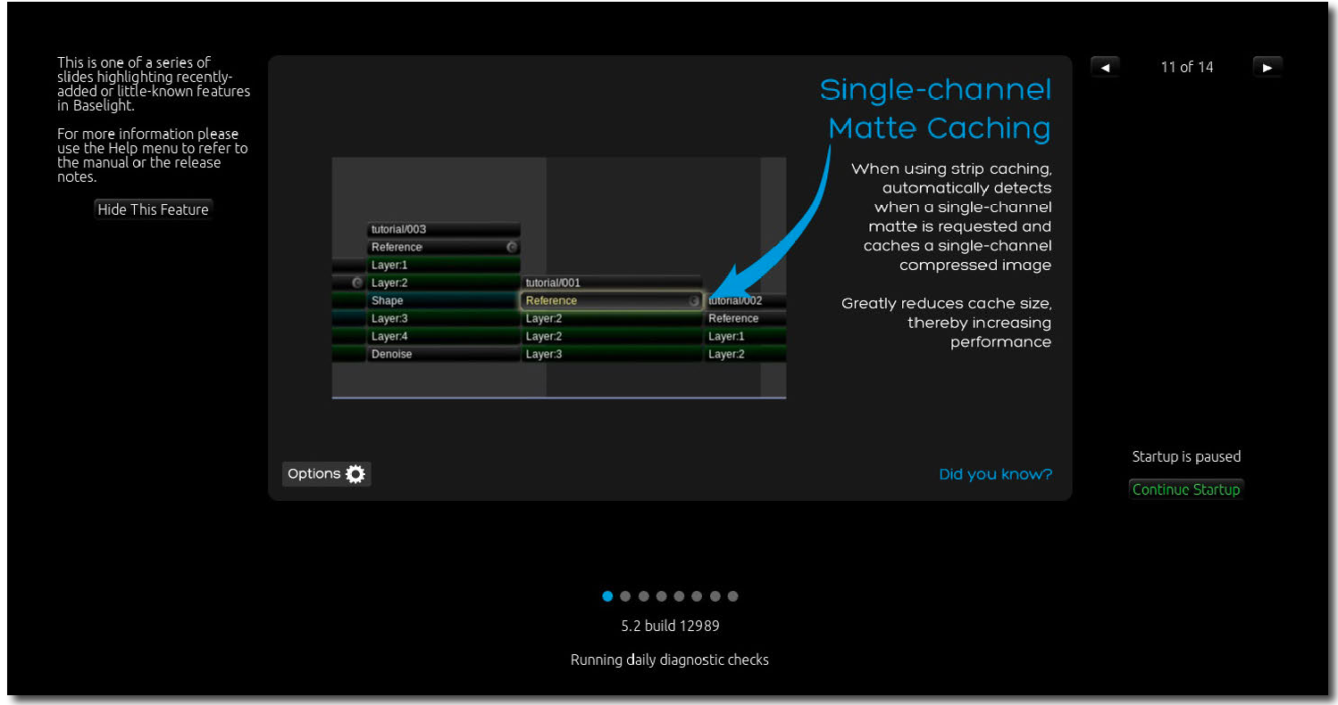

Cycle through slides

Continue startup

*Baselight splash screen displaying key feature slides*

Once the application has launched you will see a default workspace displayed in the Baselight user interface and the Job Manager opened as a floating window. If your system includes a grading control panel then it should also have been initialised and you should see appropriate labels on its buttons and screens.

## Baselight software versions

Software releases are numbered according to their version and build number. The *major* version is the first number before the point and is referred to as simply the software ‘Version’. For example **5.1.10720** and **5.2.10795** are both ‘Version 5’ software releases. The number after the first point is the ‘minor’ version number, so the examples above are 5.1 and 5.2 releases respectively. The final number after the point is the actual build number and uniquely identifies each software build we release.

Note that from Version 5 onwards, all minor versions within a major version are compatible with each other in terms of the ability to open scenes saved by a different software build, e.g. Version 5.1 and 5.2 are able to open each other’s scenes. This compatibility extends across all Baselight products including CONFORM and EDITIONS.

Scenes and jobs saved in Version 4 will need to be upgraded before they can be opened in Version 5 - see Opening Scenes from Older Software Versions on page 95.

## Key features

This version of the Baselight manual includes the following new features:

#### Key features displayed during start-up

When you start Baselight, slides are displayed to highlight recent additions to functionality. This can be disabled by clicking on the slide during start-up.

See Starting the application on page 2 for more details.

#### Single-channel matte caching

When using strip caching, Baselight automatically detects when a single-channel matte is requested and caches a single-channel compressed image. This greatly reduces cache size, thereby increasing performance.

See Input and intermediate cache on page 288 for more details.

#### New AJA SDK

With this update, Baselight supports a greater range of SDI output options, as well as HDR metadata and dynamic video mode switching, 12G-SDI stereo 4K and HFR, and 8K resolution and 4K dual output on the AJA Kona 5.

See the *Baselight Installation Manuals* in the Document Library on the FilmLight web site for more details.

#### Support for additional video monitoring devices

Baselight now supports Blackmagic SDI hardware on macOS. The following devices have been tested but other Blackmagic SDI devices should also be supported:

* UltraStudio Mini Monitor
* UltraStudio HD Mini
* UltraStudio 4K
* UltraStudio 4K Mini
* DeckLink 8K Pro

See the *Baselight Installation Manuals* in the Document Library on the FilmLight web site for more details.

Baselight also includes the following key features:

#### Comprehensive media file format support

Read and render a wide range of media file formats - for a complete list please refer to the Baselight Codec Support datasheet which can be downloaded from our website.

#### Extensive metadata

During the import process all metadata is read from the source files and imported into the local database. Powerful tools within Baselight provide quick searching, sorting and modifying of the metadata and selected data can subsequently be rendered into output files or exported for use by other systems.

#### Automatic colour space management

Regardless of the camera it was captured with, all source material is transformed accurately from its native colour space into a common colour space for grading and deliverables can be rendered into different colour spaces according to the requirements of the workflow. These colour space conversions are all performed automatically, saving a huge amount of time and providing more consistent and accurate results.

#### Full creative toolset

All shots can have full sophisticated looks applied using the same compact grading interface familiar to users of Baselight Editions for Avid and NUKE. Secondary grading features include a range of keyers and shape tools plus matte processing and auto tracking for speeding up advanced operations.

#### BLG file support

Baselight provides read and write support for BLG files and the Baselight Lens™ feature enabling powerful ‘render-less’ workflows throughout the entire post-production pipeline including on-set, dailies, editorial and visual effects departments.

Introduction

Terminology

GPU acceleration

#### GPU acceleration

All grading operations and image effects are processed using the available system GPU(s), improving overall performance and reducing rendering times.

#### Built-in Scopes

Baselight includes six different tools to help you adjust and QC your deliverables.

#### Audio syncing

Separately recorded audio files can be automatically synced to multiple source movies in a single operation; semi-automatic and manual syncing tools are also provided.

#### Simultaneous deliverables

Multiple deliverables can be generated in one pass using Baselight’s powerful render manager. Renders can also be queued and off-loaded to other networked Daylight and Baselight systems.

#### Import and export of EDLs

Baselight can import material according to a CMX or ALE list and can also export EDLs in the same format, with embedded ASC CDL grading data.

#### Works directly with FilmLight on-set systems

Baselight can import look metadata directly from FilmLight’s on-set look management system, Prelight.

For more information about the features in Baselight v5, see the Baselight v5 datasheet, available from the FilmLight web site.

## Terminology

Like any specialist system, Baselight uses some of its own nomenclature to describe specific objects and functions. To avoid potential confusion, the following is a brief explanation of some key terms used in this manual.

**Conform →** The process of assembling image sequences in the timeline according to a list.

**Cutview →** Thumbnail representation of the scene. Can be used for navigation and copy-paste operations.

**EDL →** Edit Decision List.

**Format →** The format provides a way for Baselight to store information about a sequence itself-such as the frame rate or pixel aspect ratio-that is not stored within the individual image file.

**Frame →** One of the many still images that compose the complete moving picture.

**Gallery →** A ‘bin’ to store graded shots. The contents of the gallery are independent of the scene contents and can be shared with other projects.

**GPU →** Graphics Processing Unit.

**Histogram →** RGB histogram display of the frame currently being viewed in the Image Display, which shows the distribution, in 10-bit code values, for each of the red, green and blue channels for the currently displayed frame.

**Image Display →** The monitor or projector used to display the images that you are grading. The Image Display is calibrated and controlled by Truelight to guarantee colour accuracy. Note that in multiple-view mode, several Image Windows may be shown in the same Image Display.

**Image Window →** The window within the Image Display that shows the images that you are currently working on. The Image Window may fill the Image Display or there may be several Image Windows within the Image Display in multiple-view mode.

**Job →** This is what a project is called in Baselight. The job name is often the name of the film or project currently being graded. Internally, a job is a complete database containing data for all the scenes in a project. The Job Manager is used to create and delete jobs and scenes.

**Keyer →** A keyer is designed to isolate colours so that they can then be adjusted or enhanced via the grading plugins.

**Keyframe →** A frame that is used to indicate the beginning or end of a change to the grading controls.

**Layer →** A layer essentially groups related items to make it easier to work with them on the timeline. A stack can contain multiple layers.

When a sequence is added to the Baselight timeline, it is added in an input layer, which contains information about the sequence. Grades are also inserted in layers by default; a grading layer is called an InsideOutside layer and contains the grade(s) applied to the sequence as well as links to any inputs for those grades, such as a matte created from a shape or key.

**Matte →** A matte masks specific parts of an image to allow a different correction to be applied, perhaps to highlight the detail in someone’s face or soften the colour of an object. A matte can be created using shapes, or by using a keyer to isolate certain colours.

**Metadata →** Information that is stored on a per-shot basis when a sequence strip is inserted into the timeline. This information can be pulled from the EDL or from the files themselves.

**Proxy →** A lower resolution copy of an image, used to improve Baselight interactivity and playback performance when working with high resolution images; for example, there may be proxies at half and one quarter of the resolution of the master footage. The actual proxy resolutions available for a given format are defined as part of each format.

**Scene →** Part of a Baselight project, contained within a single Timeline. A scene is a collection of shots and does not necessarily have to be a script scene. Each scene may represent a single reel or, for example, a complete commercial or a series of separate effects shots from different scenes within a feature film.

**Sequence →** A contiguous series of numbered image files. Image files in a sequence normally have a short name followed by a sequence number. For example, img0001.dpx, img0002.dpx, img0003.dpx would constitute a sequence of three frames.

**Shot →** A ‘raw’ image sequence strip in the Baselight Timeline. This is the top strip in a render stack and points to a sequence (or part of a sequence) of frames on disk. Note that the word ‘shot’ does not imply a specific shot within a script or a particular camera setup. It may refer to an event in the EDL.

**Stack →** Each image sequence is represented in the Timeline as a single strip. When an operation such as a film grade is applied to this sequence, it appears as an equal length strip below the image strip. A single image sequence strip can have any number of operations applied to it, and this column of strips in the Timeline is known as a ‘stack’.

**Stack Manager →** The part of Baselight that manages layers, and essentially groups related items to make it easier to work with them on the Timeline.

**Timeline →** Time- or frame-based ‘layer’ view of all strips in the current scene.

**UI →** The Baselight User Interface. This includes all of the on-screen controls that appear on the UI Monitor but not the contents of the Image Display.

**UI Monitor →** The monitor used to display the Baselight UI.



# Chapter 2 Quick Start

Contents

## Overview

This chapter provides a brief operational overview of Baselight. It is intended as a way to quickly get you up and running, so if you are testing a newly installed system or just eager to get going, then this is a good place to start.

In order to follow the examples, you will need to have access to the ‘Quick Start’ tutorial media files – these will have been copied onto your system if it was shipped with pre-configured internal storage, however they can also be downloaded from the training section of our website. If you are downloading the media, please follow the instructions in this chapter for details of how to copy the tutorial media into the appropriate location onto your system.

As this is just a brief introduction to Baselight we won’t be going into much detail, but all the main workflow steps will be covered in the following topics:

Starting up the system

Creating a new project Importing footage Playing back the scene Applying basic grades

Working with mixed resolutions Secondary grading

Working with audio Rendering and export

Quitting Baselight

10

11

12

16

19

27

29

37

39

43

## Starting up the system

Baselight TWO and Baselight X systems consist of a master node (which is normally installed in a rack in a machine room somewhere) and a small, desktop ‘UI host’ PC which will probably be on or close to the desk where you are working. To power up the system you will first need to go to the machine room and turn on the master node by pressing the small switch above the disk array:

Power Switch

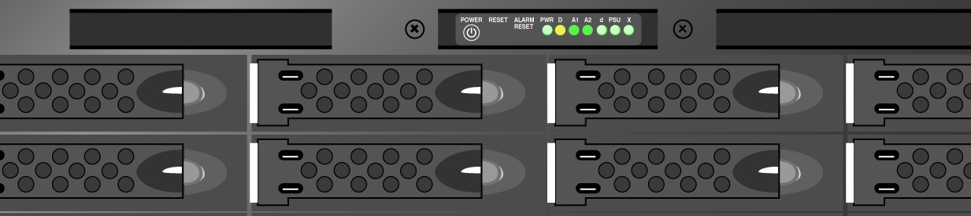

*Power switch on front of master node*

Once the master node has finished booting it will send a signal to the UI host via the Ethernet link which in turn will cause the UI host PC to wake up and boot – you don’t normally need to turn on the UI host PC manually, it should happen automatically. This whole process can take several minutes, and until it is complete you may not see anything displayed on the Baselight monitors so please be patient.

Systems which are based on a Z8 or Z840 HP workstation (e.g. Baselight ONE and Baselight ASSIST) are powered on using the button on the front of the workstation:

Power Switch

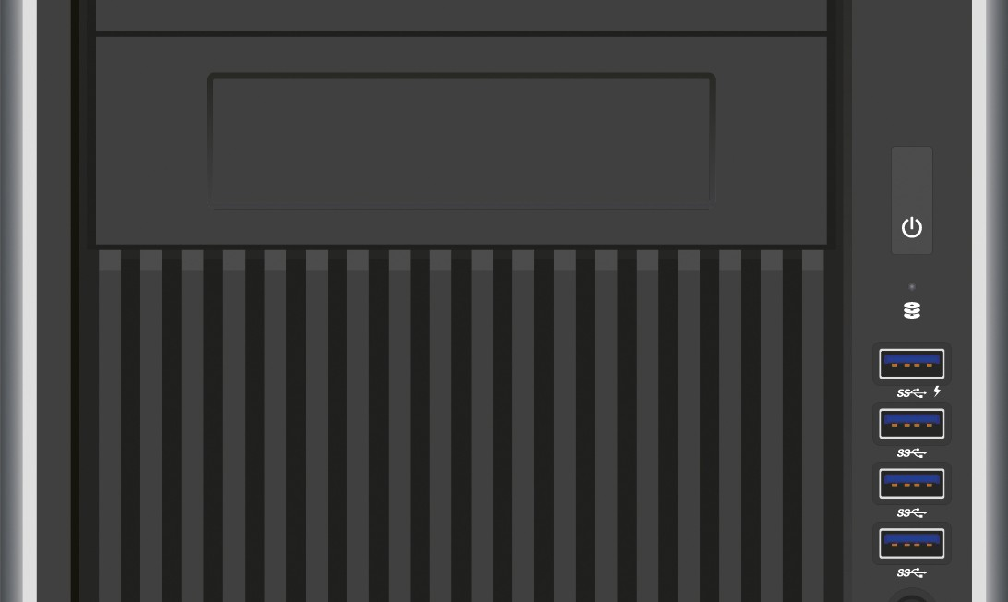

*Power switch on front of HP workstation*

Once the system is up and running you will need to log in at the Linux login screen.

#### Running the Baselight application

The application is launched from the icon which can be found on the Linux desktop.

**→** While the software is loading, a splash screen will appear giving you the current software build number.

Note that if the software licence has not yet been installed or activated you will be presented with a pop-up licence dialogue box.

Once the application has launched you will see a default workspace displayed in the Baselight user interface and the **Job Manager** opened as a floating window. If your system includes a grading control panel then it should also have been initialised and you should see appropriate labels on its buttons and screens.

## Creating a new project

The following steps will take you quickly through the process of creating a new Baselight ‘*job*’ and then a new

*scene* within the job, ready to import footage and apply grades.

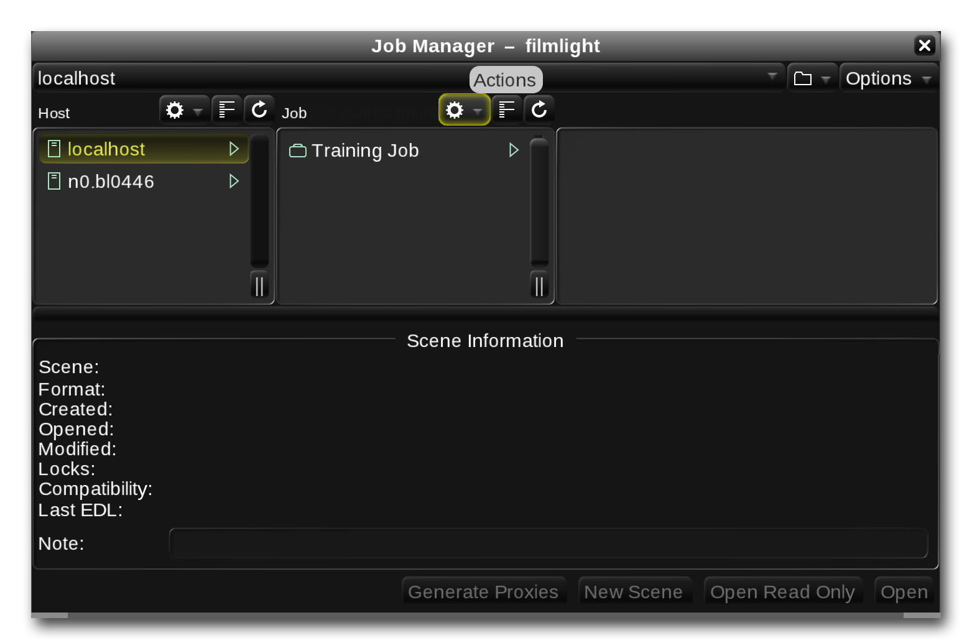At this point, having launched the application, you should see the Job Manager window on the screen (it opens automatically when the application starts up). If you have closed the window, you can open it again by pressing **WIN+J** on the keyboard or by selecting **Job Manager** from the **Views** menu at the top of the main UI monitor. It should look something like the picture below.

*Job Manager – actions button*

Now follow these steps to create a new job:

1. Click on the  **actions** button at the top of the ‘Job’ column (the second column) in the

##### Job Manager.

1. Select ‘New Job’.
2. Enter a name for the job and press **Enter**. Note that in Baselight, a ‘job’ contains all the grading work you do on a single project. Note that the newly created job will appear in the **Job** column with its name highlighted, indicating that it is currently selected.
3. Now click on the  **actions** button at the top of the ‘Scenes’ column (the next column along) and select ‘New Scene’. Enter a name for the scene. In Baselight, a scene is equivalent to a single timeline – it does not imply a scene in a script for example.
4. Click the **Scene Template** button and select **FilmLight Template** from the drop-down list.
5. Click on the **Working Format** button and choose **HD 1920x1080**.
6. Set the **Working Frame Rate** to match the frame rate of your intended deliverables – this would normally match the frame rate of your source material.
7. Save the settings for the new scene and close the window by clicking on the **Ok** button.

At this point a pop-up box may appear asking you to choose a format for the ‘Per-Job’ gallery for your new job. Galleries are used to save and recall grades – see the Galleries & Cuts View chapter for details. Simply click on the **Ok** button to close the box and continue.

**→** A new scene will now have been added to the job you created – details of the scene are displayed in the Scene Information section at the bottom of the Job Manager. Note that both the job and scene are automatically stored in the database when they are created.

1. You can now close the Job Manager window by clicking on its ‘X’ button at the top right- hand corner, or by pressing **WIN+J** on the keyboard.

## Importing footage

Now that you have created a new, empty scene, the next step is to import the footage into the scene. Baselight can read a very wide range of media file formats including movie files and image sequences. Single image frames can also be imported if required (most still image formats are supported).

There are two different methods for adding media to a scene:

* Manually browsing through source volumes and selecting the material to add.
* Using an EDL to ‘conform’ a scene which was edited on another system such as an editing workstation.

In this chapter we will use the first method to find, select and add media to the timeline – full details of the EDL conform process can be found in the Conform & Consolidate chapter.

#### Browsing and adding media using FLUX Manage

The following example assumes that you already have the tutorial footage on your local media RAID, if not, you will need to copy the media over first. If your system does not have any local media storage, or you would prefer to work with media stored on a remote or external volume, then this is also possible (see the note boxes in this section). The following steps use FLUX Manage, Baselight’s built-in media management tool:

1. Open **FLUX Manage** by selecting it from the **Views** menu at the top of the screen, or by pressing **WIN+B** on the keyboard.

**→** The **FLUX Manage** window will open showing a ‘**Browser 1**’ tab – similar to the picture below. For a more detailed description of this window please see the FLUX Manage chapter.

Volume selector

Browser area

Current path button Bookmark button

Information area

Grid and List View buttons.

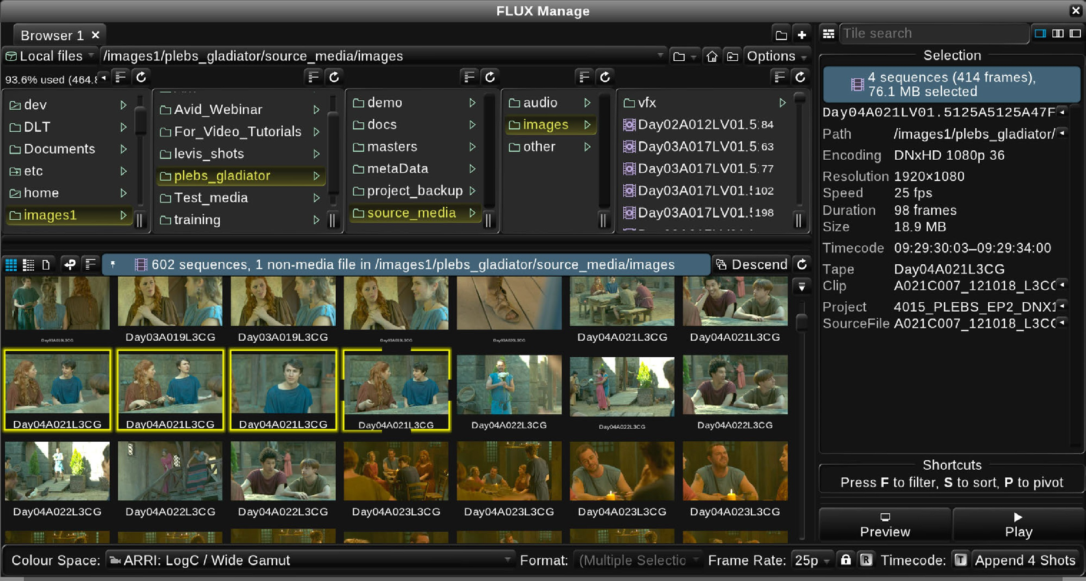

Thumbnail grid Selected shot(s)

Input format

Preview buttons

Append button

*FLUX Manage*

1. Click on the **volume selector** button to view a drop-down list of all the storage volumes which your Baselight system can access. If your system has local RAID storage this will appear as a volume pre-fixed with the machine name, for example ‘bl01234-images’.

If your footage is on remote storage such as a SAN or NAS, then the shared volume will also appear in the drop-down list as long as the system has been configured correctly. Note also, that any portable drives plugged into the Baselight system will also appear in this list – please see the Media & Metadata chapter for full details.

1. Select the volume containing the tutorial footage by clicking on it in the list.

**→** The contents of the volume will be listed in the left-hand column, similar to the example above.

1. Click on the ‘tutorials’ folder and then on the ‘quick-start’ folder.

**→** A list of the media files contained in the folder will appear in the main part of the browser window and thumbnails or details will appear in the lower part of the window (depending on the setting of the **grid** and **list view** buttons).

If you have downloaded the tutorial footage and want to copy it onto the local Baselight storage you can use the copy tool built into FLUX Manage – instructions are included on page 15. Note that this is the preferred way to copy media onto the internal storage as the FLUX Manage tools have been optimised for copying large media files and sequences efficiently while avoiding fragmentation of the file system.

1. Click on the **Grid view** button (see page 151) to display thumbnails for the media files and then click on one of the thumbnails.

**→** The outline of the thumbnail will turn yellow to indicate that it is selected and metadata and other details will appear in the metadata area in the FLUX Manage window. Multiple shots can be selected by holding down **CTRL** and clicking on additional shots to add them to the selection. Note that when multiple shots are selected, summary details will be shown in the metadata area.

1. Click on the first thumbnail to select it, then hold down the **SHIFT** key and click on the last thumbnail.

**→** This will add all the shots to the selection.

Baselight provides several other methods for selecting and de-selecting a group or range of shots – please see the FLUX Manage chapter for details.

1. Click on the **List view** button  and then click on the **Filename** column heading to sort the list of shots into ascending filename order – the sort order is indicated by a downwards pointing arrowhead to the right of the column heading.
2. Finally, click on the **Insert Shots At Cursor** button at the bottom right-hand corner of the FLUX Manage window.

**→** The selected shots will be added to the scene and will appear in the Timeline.

1. The FLUX Manage window can now be closed by clicking on its ‘X’ button. You can also toggle the window open and closed using the **WIN+B** keyboard shortcut.

#### Using FLUX Manage to copy footage

As mentioned above, FLUX Manage provides tools to copy media between different folders and volumes. If your footage is on a portable drive or a networked storage volume, you can copy it to the local storage on your Baselight system by following the steps below.

1. If you have already added media to your scene from a portable or remote volume you should remove it first to avoid confusion. This can be done now simply by pressing **CTRL+Z** on the keyboard to undo the last action (which was to add the media to the scene).
2. Open FLUX Manage again and select the media you want to copy (the shots may still be selected from the previous steps).
3. Click on the ‘**Two panes**’ button at the top right corner of the FLUX Manage window:

Two panes button

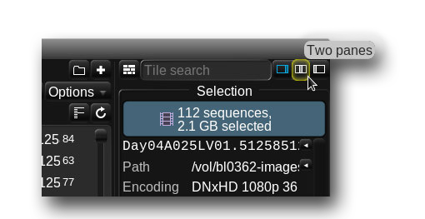

*FLUX Manage – Two panes button*

**→** A second browser section will open on the right side of the FLUX Manage window with a ‘**Browser 2**’ tab selected.

1. Click on the **volume selector** button on the right-hand side under the Browser 2 tab and select the internal storage – this will normally be listed as something like ‘**bl0123-images**’ or ‘**Local filesystem**’, but the actual volume name will depend on the system configuration.
2. Browse to the directory into which you want to copy the footage – if necessary you can create a new directory by clicking on the **Create folder** button:

Create folder button

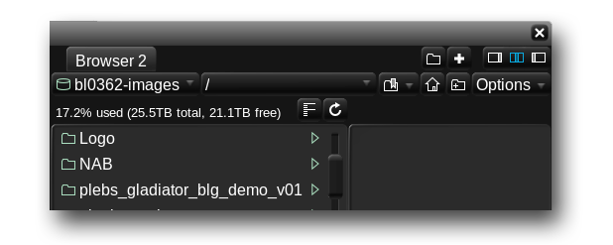

*FLUX Manage – Create folder button*

1. To copy the shots you selected on the left-hand side, simply click-and-drag them across to the appropriate directory on the right. **→** A green outline will appear indicating the destination into which the files will be copied.
2. As soon as you release the mouse button, or lift up the tablet pen, a ‘**Copy Options**’ dialogue box will appear. For the purposes of this exercise you can simply click on the **Ok** button, but for an explanation of the options available please refer to Copying Media in the FLUX Manage chapter.

**→** The copy process will be added to the Baselight system’s media processing queue and will appear in the **Operation History** section of the FLUX Manage window along with a bar showing its progress.

1. Once the copy process has completed you can switch back to the single pane FLUX Manage view by clicking on the button on the left of the **two panes** button.
2. Now that the media files are on the local storage you need to select the local storage volume in the ‘**Browser 1**’ tab and browse to their location.
3. Follow the steps on page 14 to select the tutorial footage from its new location on the local image storage and then add it to the scene.

## Playing back the scene

Before continuing, please switch to the **‘Simple’ Workspace** by selecting it from the **Views** menu at the top of the screen or by pressing **WIN+2** on the keyboard.

Quick Start

Playing back the scene

Navigation controls

To start playing back the shots in your scene simply press the **Space** bar on the keyboard or, if you have a control panel connected, press the play button (note that Baselight CONFORM and Baselight ASSIST do not support hardware control panels). Pressing **Space** or the play button again will stop playback.

By default, Baselight automatically sets the colour space for each shot when it is imported. If a shot appears very washed out or has too much contrast then this is most likely because it has been tagged with the wrong input colour space. You can easily change the input colour space of shots after they have been imported – please see the section on modifying sequence operator parameters on page 115 and also the chapter on Colour Space Management.

#### Navigation controls

You can jump from one shot to the next by pressing **X** on the keyboard; pressing **Z** will jump back to the previous shot. When playback is stopped, the left and right arrow keys on the keyboard will step forwards and backwards through the shot by single frames. Pressing **CTRL+Home** will take you right back to the first frame in the scene and **CTRL+End** will jump to the very end of the scene.

Several other keyboard shortcuts are available to navigate through the scene as well as for many other functions within Baselight – details can be found in the *Keyboard Shortcuts* document under the **Help** menu at the top of the Baselight user interface screen.

A set of on-screen navigation controls are also provided in the **Play Controls** view:

Play options button

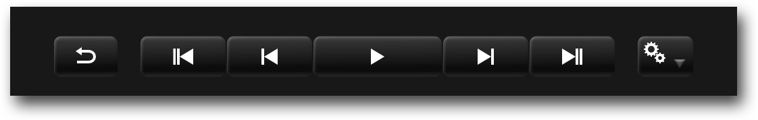

*On-screen Play Controls*

If you cannot see the on-screen play controls within your UI screen workspace, switch to the **‘Simple’ Workspace** under the **Views** menu at the top of the screen.

#### Enabling the counter overlay

While playing back your shots, it is often useful to be able to view information related to the footage. Baselight provides an overlay which displays certain metadata within the image display. To enable the overlay function, press **K** on the keyboard or enable the **Show Counters** button in the **Cursors** view. Note that if the cursors view is not currently visible, it can be opened as a window by selecting it from the **Views** menu.

**→** A set of default counters including the shot timecode and tape ID will be displayed. Other metadata can be added to the overlay using the options in the cursors view – see the section on cursors (page 276) for details.

#### Navigating using the mouse

The mouse (or tablet pen) can be used to quickly jump to a specific shot or to drag through shots to locate a specific frame:

1. Open the **Shots** view from the **Views** menu at the top of the screen or using the **WIN+H** keyboard shortcut. Note that if the current UI workspace already includes the Shots view it will be briefly outlined with a yellow glow to show you where it is.
2. Switch the Shots view to display a thumbnail grid by clicking on the  button at the top.
3. To jump directly to a shot, simply click on its thumbnail in the Shots view – the main image display will switch to showing the selected shot. Note that you can do this without stopping playback; Baselight will continue to play back from the shot you clicked on.
4. To drag through the frames of a shot, move the mouse pointer towards the top edge of its thumbnail until you see a yellow scrub bar appear:

Scrub bar

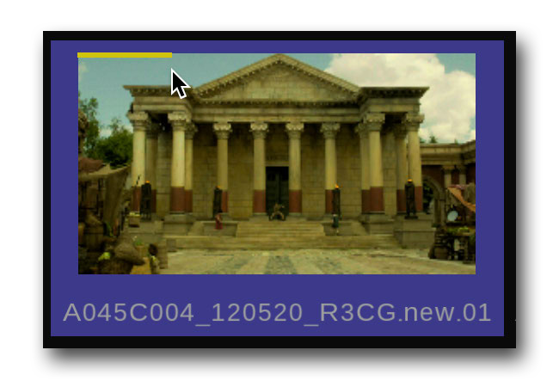

*Thumbnail scrub bar*

Click and drag to the left and right to scrub through the shot – the frames will appear on the main image display.

1. To drag through the entire scene, click on the top of the cursor and drag it along the timeline:

Timeline cursor

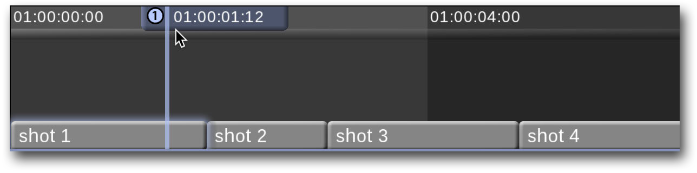

*Timeline cursor scrubbing*

The **Cuts View** can also be used to navigate through the shots in a scene – this and other functions of the Cuts View are covered in the Galleries & Cuts View chapter.

#### Zooming and panning with the mouse

The mouse (or tablet pen) can be used to zoom the image or timeline: position the pointer over the image display or timeline, press and hold both the **CTRL** key on the keyboard and the *middle* mouse button (or *lower* side-switch on the pen) and then drag to the left or right.

**→** The image or timeline will zoom out or in respectively. Note that if you are zooming the timeline, it will zoom horizontally with left/right movements of the mouse and vertically with up/down movements.

To pan the image display or timeline, the mouse or pen action is the same as zooming, except you only hold down the middle mouse button (or lower pen side-switch) while dragging – you do not hold the **CTRL** key.

To reset the image display zoom and pan, press **F12** on the keyboard; to reset the horizontal zoom of the timeline, press **F7** (the timeline will zoom to fit the entire scene); to reset the vertical zoom of the timeline, press **SHIFT+F7**.

For more details about zooming and panning the display, please refer to the UI & Workspaces chapter.

## Applying basic grades

Now that you have organised all the shots in your scene you are ready to start applying colour grades to your shots. However, before proceeding, there are a couple of things you should check to ensure that the colours you are seeing on your grading display accurately reflect the actual colours you are working with.

#### Checking the colour space journey

Baselight uses a fully colour-managed image processing pipeline which means it is important that the correct colour spaces are specified at different points in the system. As has already been mentioned, the input colour space for each media file is set automatically when it is added to a scene. The other colour space settings will have also been set automatically according to the template you used when you created the new scene (see page 11). Before starting to grade, you should check they are correct. The simplest way to do this is to open

Quick Start

Applying basic grades

Checking the colour space journey

the **Colour Space Journey** view – select it from the **Views** menu at the top of the screen or press **SHIFT+WIN+J**

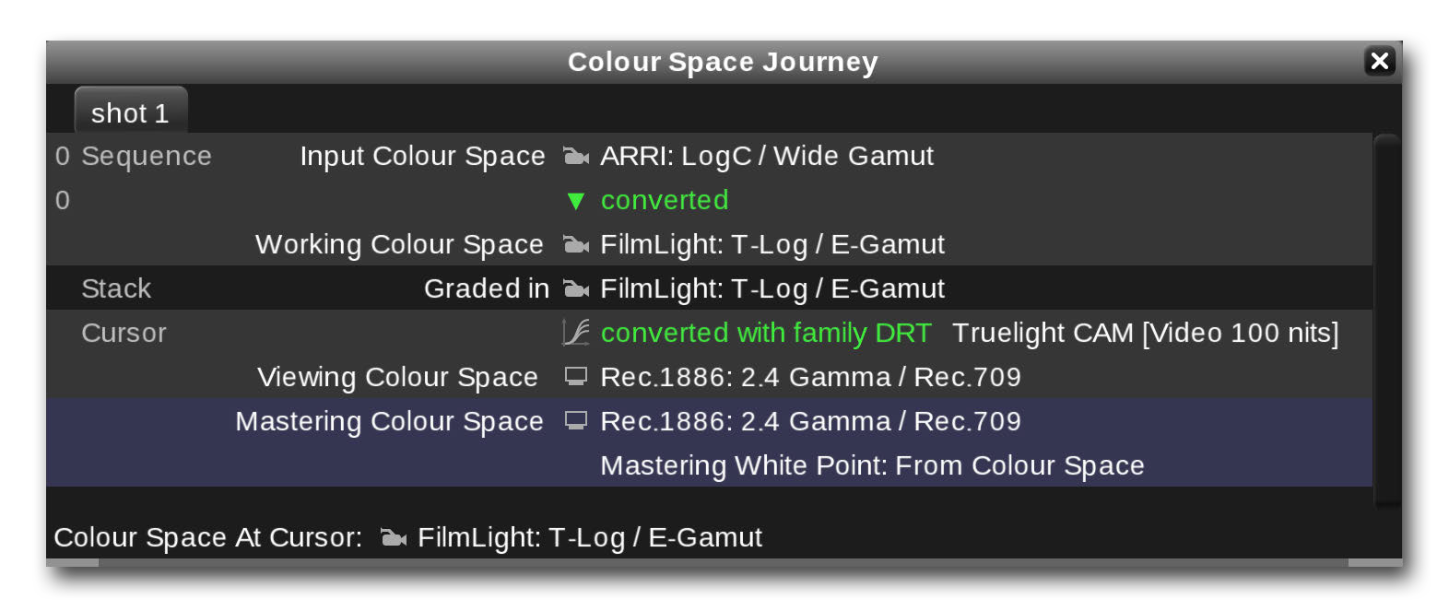on the keyboard **→** The window will open as shown in the example below:

*Colour Space Journey view*

A more detailed explanation of the different steps in this ‘journey’ is provided later in this manual and advanced information is also available in the documentation and video tutorials on the FilmLight website; however there are a couple of things you should note:

**→** The **Working Colour Space** defines the colour space within which the grading controls will operate. In this example it was set automatically by the ‘FilmLight’ scene template. For the purposes of this example there is no need to change this but you may choose to grade in a different colour space if you prefer. It can be changed on the **Format & Colour** page of the **Scene Settings** view (accessed from the Views menu or by pressing **WIN+S**).

**→** The **Viewing Colour Space** should be set according to the display you are using to view the images. The setting here was also preset by to the scene template, however it should be changed if necessary, to match the colour space of the display you are using:

1. Open the **Cursors** view from the **Views** menu (this view may already be open within the current workspace in which case it will be briefly outlined with a yellow glow).
2. Click on the **Viewing Colour Space** button and choose the correct setting from the pop-up menu – display colour spaces are listed with a monitor icon to the left of their name. Baselight provides colour spaces for all standard displays used in post production. It is worth pointing out that colours will only be totally accurate if the display you are using is accurately calibrated to the colour space you have chosen.
3. Now click on the Cursors view actions button  and select ‘**use these cursor settings when scenes in the job are opened**’ from the pop-up menu. This will ensure that the same viewing colour space will be used for each scene you add to this job. You can later clear this option if required.

**→** The final point to note is that when you are working with high dynamic range/wide gamut footage (i.e. log encoded or RAW media) Baselight will automatically apply an appropriate **Display Rendering Transform** (DRT) to convert the colour space into the viewing colour space for the image display. Again, this is preset in our example by the scene template but

can be changed to a different DRT via a setting in the **Format & Colour** page of the

**Scene Settings** view.

For the purposes of this exercise, all you need to do is check, and if necessary change the **Viewing Colour Space** as detailed in steps 1 to 3 above.

#### Adding a grading layer

In Baselight, grades and other effects are applied to the source media using layers. There are several ways to add a new layer; the following example will describe a couple of them but please refer to the later sections of this guide for further details.

1. If you are not already viewing the **‘Standard’ Workspace**, switch to it by pressing **WIN+1** on the keyboard.
2. Select the shot by **CTRL**-clicking on it in the **Cuts** view (you can also use one of the other navigation methods described earlier to select the shot you want to work with) **→** The selected shot will appear in the image display and the cursor will be positioned within the thumbnail in the Cuts view:

Cursor

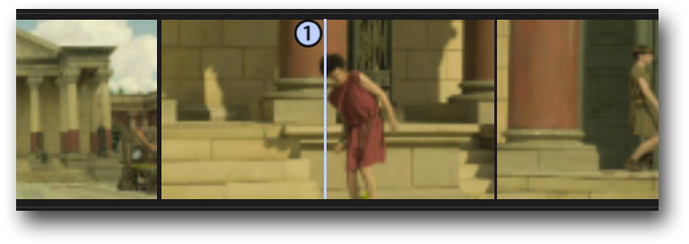

Selected shot

*Currently selected shot in Cuts view*



Note that there may also be a dark blue outline around the thumbnail – this is known as the Dark Blue Square or ‘DBS’. It is used for certain copy-paste operations and will follow the shot containing the cursor if the ‘DBS Lock’ button is enabled. The DBS has no effect when adding new layers so you can ignore it for now.

1. Add a new layer by pressing **P** on the keyboard. You can also add a layer by clicking on the

**Layer Manager** button at the top of the screen and then clicking on the green ‘**+**’ button:

Layer Manager button

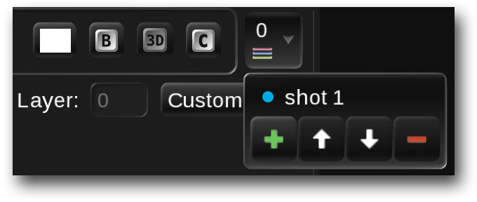

Add layer

*Layer Manager – add new layer*

**→** A new layer will be added to the shot and will appear in the Layer Manager as ‘**layer:1**’. In the timeline you will notice a new strip has been added *below* the shot’s input sequence strip.

You will also notice that the parameters view – the main area of the UI screen – is now showing a set of grading controls and to the right of these controls is a column showing different types of grading operator:

Selected grading operator

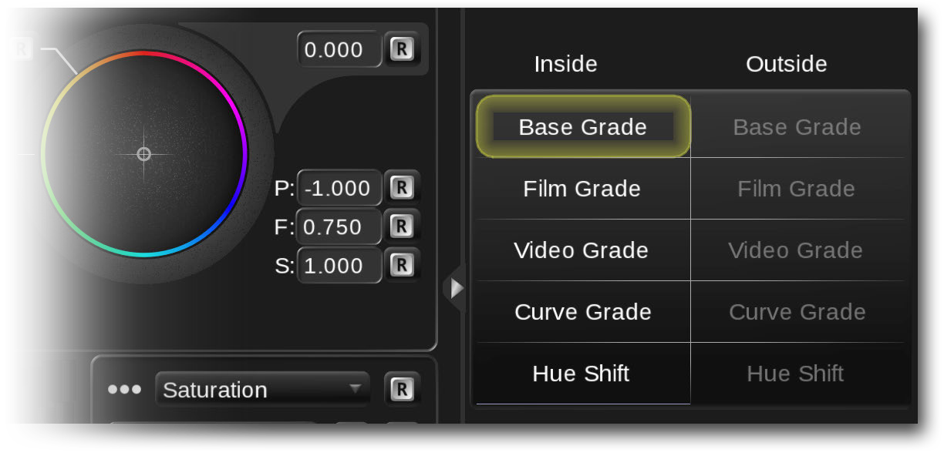

*Grading operators for the current layer*

1. The currently selected grade type is highlighted in yellow – note that the initially selected operator for each grading layer is specified as a default in the user preferences. To choose a different one, simply click on it in the grading operators column. However, for this exercise make sure that the ‘Base Grade’ operator is selected.

**→** The controls for the Base Grade operator will appear in the parameters view:

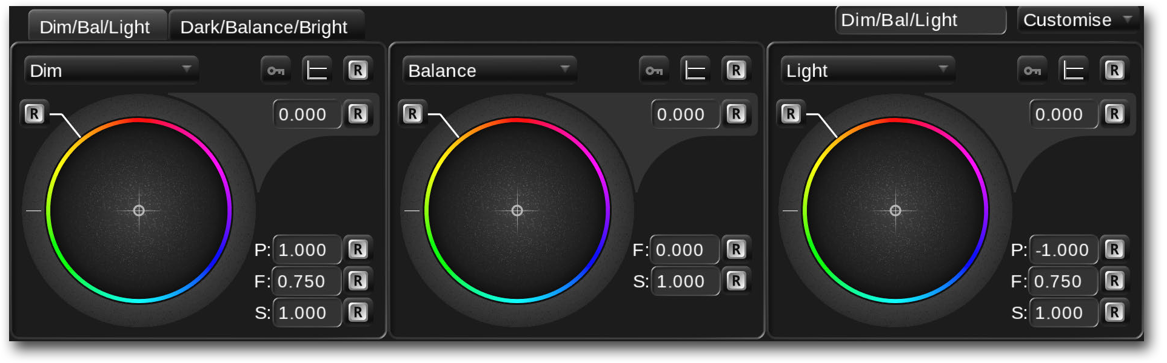

*Base Grade controls – Dim/Balance/Light tab selected*

1. Make sure that the **Dim/Bal/Light** tab is selected at the top-left of the grading controls and then try adjusting the following on-screen controls to see what affect they have on the image:

**Balance**, **Dim** and **Light** – the ‘virtual trackballs’ each have a ring and a ball control. To adjust them, simply click and drag with the mouse (or tap and drag with a tablet pen) in the same way you would move a physical control with your fingers. If you release the mouse while dragging on a ball control you will see that it continues to move a little, simulating the inertia of a physical ball.

1. Now select the **Dark/Balance/Bright** tab **→** The main grading controls will change to **Dark**, **Balance** and **Bright**. Try adjusting these to see what affect they have on the image.

**→** You will notice that the **Balance** control provides an overall adjustment to the exposure and colour balance of the image and that the **Dark**, **Dim**, **Light** and **Bright** controls have an affect which is restricted to different ‘lightness’ bands across the tone range of the image.

To reset any of the controls, simply click on the corresponding  button in the UI.

**→** Note that you can also undo any changes you make by pressing **CTRL+Z** on the keyboard and redo them again by pressing **SHIFT+CTRL+Z**.

1. Finally, try adjusting the **Flare**, **Contrast** and **Saturation** values in the lower section:

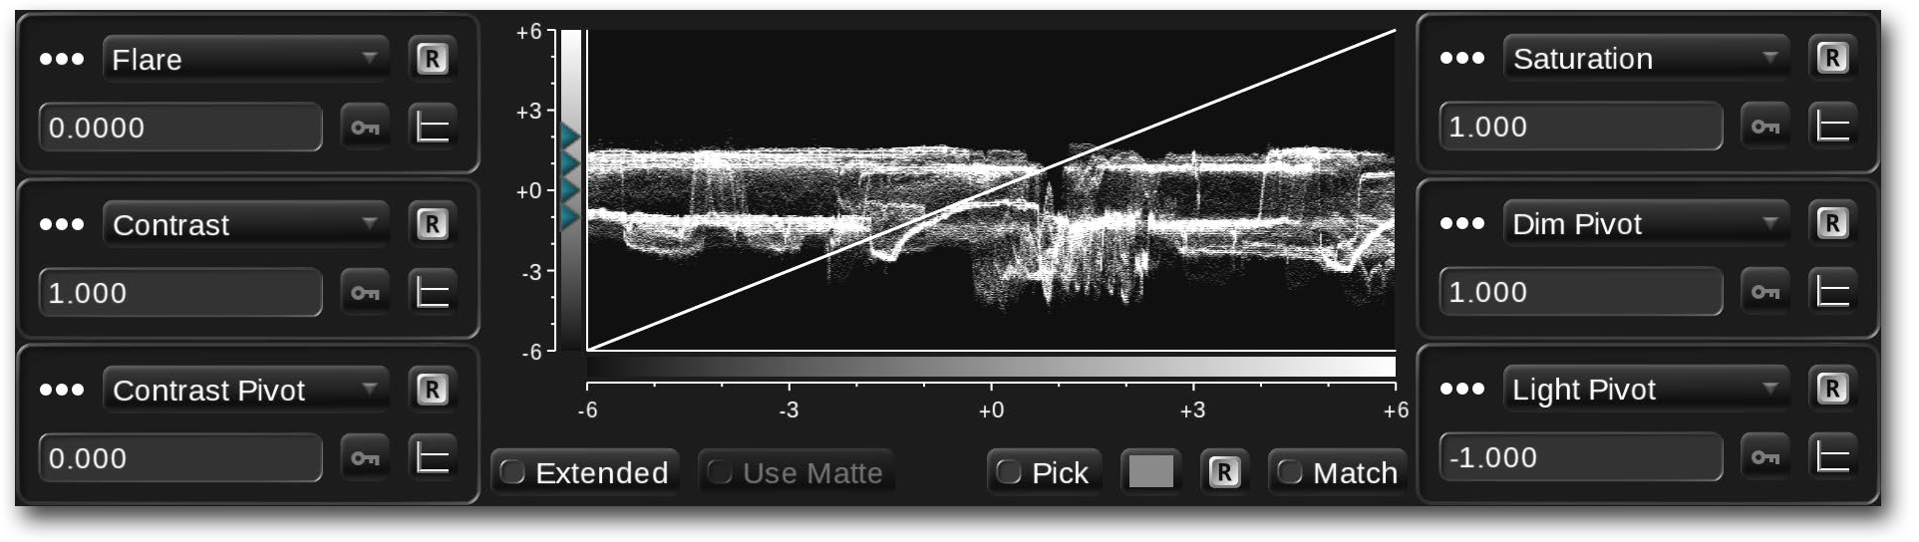

*Base Grade controls – lower section*

Quick Start

Applying basic grades

Adding more layers

Note that these are not mapped onto on-screen controls by default, however they can be adjusted interactively by clicking in the numeric field and then, while still holding down the mouse button (or holding down the pen tip), drag around the field with a circular motion – as if you were rotating an on-screen rotary control. The values will increase when you make clockwise rotations and decrease with anti-clockwise rotations. Note that the field background turns dark blue whilst this ‘gestural’ control mode is active:

Click-and-hold in a numeric field, then drag the pointer in a circular motion to simulate an

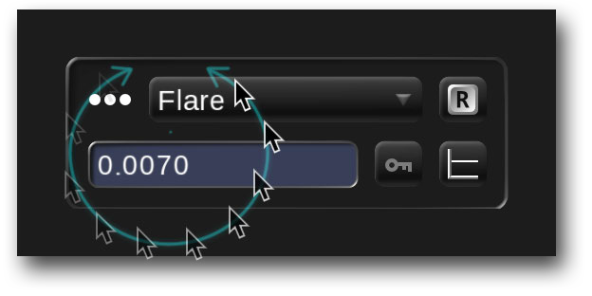

on-screen rotary control.

*Gestural control operation*

**→** As you adjust the **Flare** control you will notice that the black ‘cut-off’ point of the image varies. The **Contrast** control changes the *overall* contrast or ‘gain’ of the image and the **Saturation** control varies the *overall* ‘amount’ of colour, as you might expect.

An indication of the combined effect of these controls is provided by the waveform display in the lower half of the **Base Grade** parameters (see the example on the previous page). You are encouraged to try adjusting all the controls in the Base Grade on a range of different images to fully appreciate what affect they have. Full details can also be found in the Base Grade section in the Basic Grading chapter ??? as well as video tutorials on the FilmLight website.

#### Adding more layers

If you are just applying a basic colour adjustment to a shot then a single grade may be all that is needed. However, for more complex adjustments you will need to use multiple grading operators. You will have noticed that there are additional grading operators in the column to the right of the grading controls. These provide other types of grading tool. It is possible to add another operator within the *same* layer, however Baselight supports an unlimited number of layers per shot so unless you *need* to use multiple operators in the same layer, it is recommended to add a new layer for each additional grading operator you want to use.

There are several reasons why you may want to use of multiple operators in the same layer. These will be discussed later in this manual

The purpose of this guide is to give you a quick introduction to Baselight rather than to give a detailed explanation of the different grading tools. However, please feel free to experiment with the different grading controls and also the other types of grading operator.

If your system includes a grading control panel then of course you can use the trackballs, knobs and buttons to adjust the corresponding parameters of the different grading operators. Please consult the relevant control panel user guide for details.

1. To reset the current grade, press **CTRL+Delete** on the keyboard or right-click on the grading operator in the operators column and select **Reset Operator Entry** from the pop-up menu

**→** All the parameters for the current operator will revert to their initial values. You will also notice that the operator name will return to a white colour (it turns blue when the operator is affecting the output).

1. Operators can also be temporarily bypassed, so they do not affect the output, by clicking on the bypass  button below the operators column or by pressing **CTRL+SHIFT+F11** on the keyboard **→** Bypassed operators appear with hatching over them in the operators column and ‘B’ in the button turns red. Note that this is a toggle function.

#### Viewing and selecting the layers

You will have noticed that the image on your grading display shows the *combined* effect of the layers or layer that you have added. Layers are applied to the image in the order they were added – i.e. Layer 1 (containing the Base Grade) is applied to the input and then Layer 2 (containing the Film Grade) is applied to the output of Layer 1 and so on. If you double-click on the shot’s thumbnail in the Cuts view, a pop-up **Layer view** will appear showing you the effect of each layer (note that the Layer view can also be opened as a separate window by selecting it from the Views menu). (note that the Layer view can also be opened as a separate window by selecting it from the Views menu).

Ungraded input image

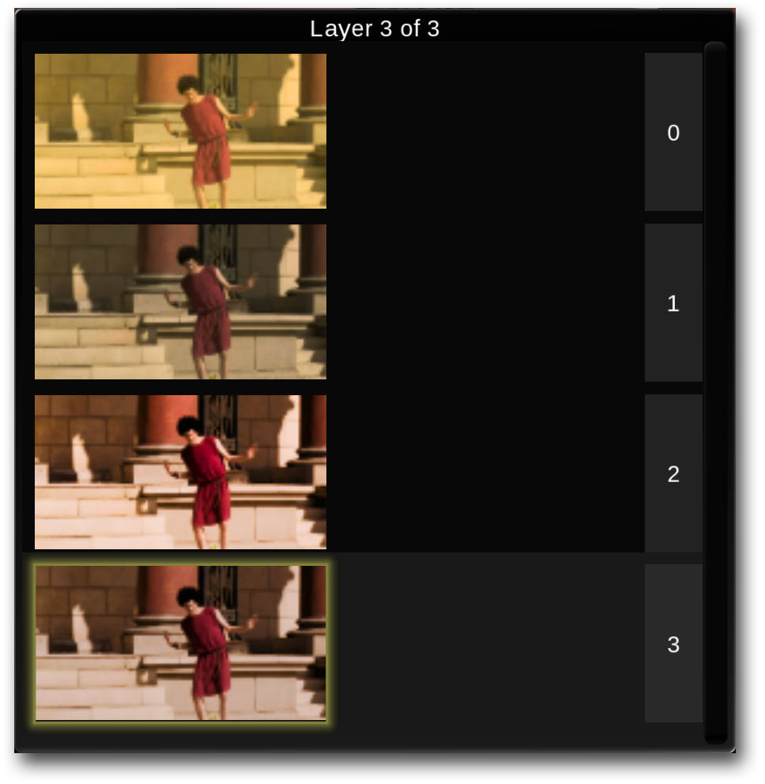

Base Grade added

Film Grade added

Video Grade added

Selected layer

*Layer view showing source and three grade layers*

Note that in Baselight, layers are *always* applied from the *top down*, unlike many popular editing applications which apply layers from the bottom up.

As well as providing a useful visual reference for each layer, the Layer View provides a way to quickly go back and adjust any of the grades **→** Simply click on the thumbnail in the Layer view and the selected grading controls for that layer will be loaded back into the parameters view.

For example, click on layer 1 **→** A yellow glowing outline will appear around the selected layer’s thumbnail in the Layer view (the selected layer ‘strip’ in the timeline will also be highlighted with a yellow glow), however you will notice that the output on the main image display still shows the *final* output with all the layers applied. This is because the viewing mode is set to display the final output by default. Follow the steps below to view the output of the selected layer:

1. Find the **Cursors** view within the current workspace – hint: if you can’t see where it is, select **Cursors** from the **Views** menu at the top of the screen **→** A yellow glowing outline will appear briefly around the view in the UI.
2. Click on the **add options** button  at the left-hand side of the Cursors view and add the **Rendering** option from the pop-up menu (this option is initially hidden) **→** A new **Rendering** mode button will appear in the Cursors view:

Add options button

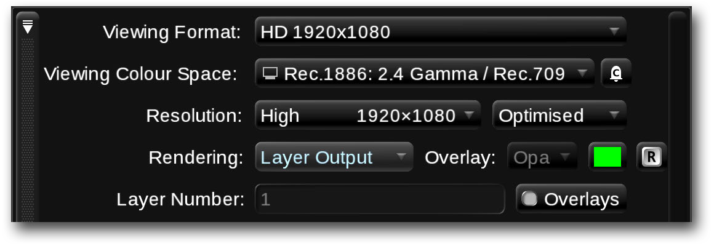

Cursor rendering mode button

Current layer

*Cursors view – layer output viewing mode*

1. Click on the **Rendering** button and choose **Layer Output** from the pop-up menu.

**→** The main image display will now show the output of the current layer.

1. To return to viewing the final output again, select **To Row Cursor** from the cursor **Rendering**

button.

1. If you want to bypass the whole layer, which will temporarily remove the effect of *all* the operators in the layer, click on the  toggle button at the top of the screen (above the grading operators column) or press **CTRL+F11** on the keyboard **→** Bypassed layers appear with hatching over them in the Layer view. The layer strip in the timeline is also hatched when it is bypassed.
2. If you want to completely remove a layer, select it in the Layer view or select its strip in the timeline, and then press **SHIFT+P** on the keyboard.

## Working with mixed resolutions

Before continuing, we will look briefly at the way Baselight converts between different resolutions and aspect ratios using ‘formats’. For further information about formats and format mappings please refer to the Formats chapter.

If you have been following the examples in this quick start guide you may have noticed that the ‘**Working Format**’ which was defined when the scene was originally created (see page 12) and also the ‘**Viewing Format**’ in the Cursors view (see page 27) are both set to ‘**HD 1920x1080**’.

The **Working Format** defines the resolution (and aspect ratio) at which the images will be processed internally within the scene. It is effectively defining the ‘format’ of the timeline. The **Viewing Format** defines the resolution (and aspect ratio) at which you are currently viewing the images from the cursor. The Viewing Format would typically match the Working Format, but it doesn’t have to. For example, you may have a project which will be delivered at both full HD (1920x1080) and also as a lower resolution version at

1280x720. In this case you would set the Working Format to 1920x1080 and also the Viewing Format while doing the main grading work. However, at any point you may want to check what the 720p version would look like – you can do this by switching the Viewing Format temporarily over to 1280x720 (using the setting in the Cursors view).

#### Format mappings

Baselight uses ‘formats’ to define ‘mappings’ between media which has different resolutions and/or aspect ratios. When each shot is added to the scene, it is tagged with an ‘**Input Format**’ which defines its horizontal and vertical resolution and also its pixel aspect ratio. This information is derived from the media file, although note that some file formats do not provide *pixel aspect ratio* information so this may need to be added manually if the pixels are not square.

When a shot is played back, a geometric transform is applied which converts or ‘maps’ it into the Working Format of the scene. By default, the image is scaled evenly so that it fits the width of the scene’s working format:

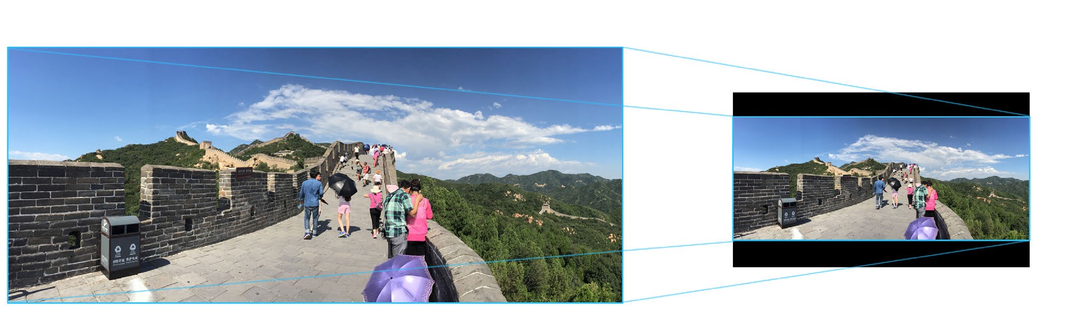Input Format (2.39:1) - 4K ‘scope’ Working Format (1.78:1) - HD 1920x1080

*Mapping between Input and Working Format*

As can be seen from the example above, if the aspect ratio of the input image is wider than the working format, then it will appear ‘letterboxed’ in the image display. On the other hand, if the input image has a

narrower aspect ratio than the working format, then the top and bottom of the image will be outside the visible area of the image display:

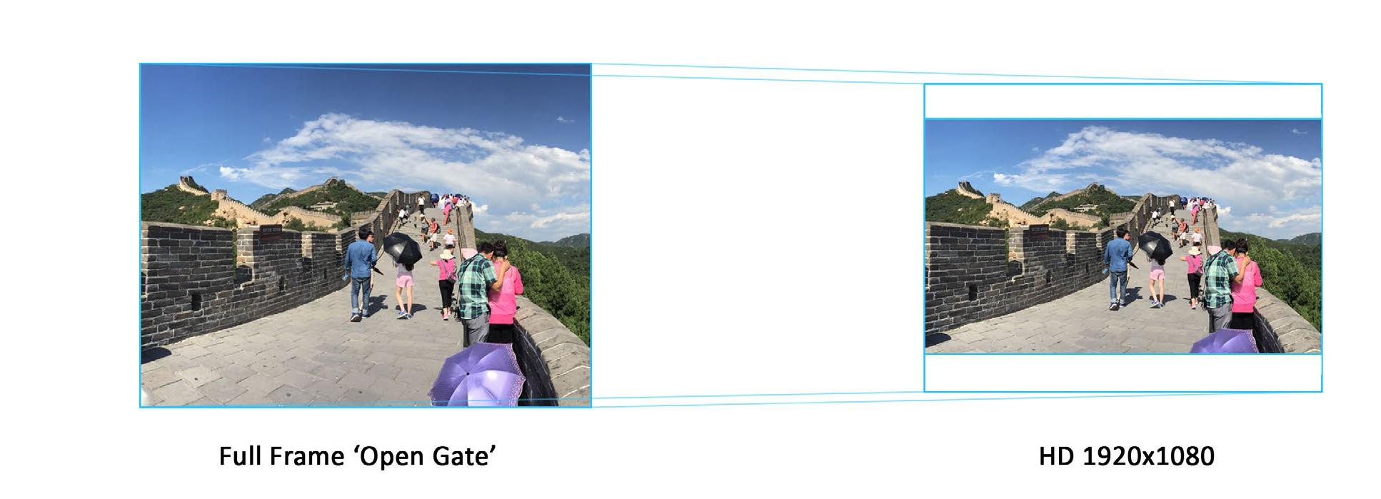

Input Format (4:3)

Working Format (1.78:1)

*Input ‘taller’ than Working Format*

In many cases this *default* mapping will be adequate as the DOP will have framed the shot with the final aspect ratio in mind. However, there may be situations where you want to adjust the vertical shift of the mapping to see more of the hidden ‘head’ or ‘foot’-room of the image.

Format mappings are also applied when you render to an Output Format which has a different resolution or aspect ratio to the working format, or if you select a cursor Viewing Format which is different to the working format. Again, the same ‘default’ mapping (fit width) will be used unless you have specified a custom mapping between the working format and the output (or viewing) format.

Baselight will apply these default mappings automatically unless a specific mapping has been defined between two ‘named’ formats. Full details can be found in the Formats chapter later in the guide.

## Secondary grading

When working through the examples in the section on adding a grading layer, you will have noticed that the adjustments you made to the grading controls affected the whole image. An overall grade in Baselight is known as a *primary* grade. In many cases however, you will want to affect only certain parts of an image – just the highlights for example, or perhaps just the blue hues of a sky. You may have scenes where you need to restrict the grade to just a shape within an image, for example to darken the corner of a room.

In this section we will take a brief look at some of the tools available to do selective or *secondary* grading.

#### Hue Shift

The first example of selective grading uses the **Hue Shift** operator to adjust the colours in an image separately from one another:

1. Add a new layer to the current shot by pressing **P** on the keyboard and then select the

**Hue Shift** operator in the operators column.

1. Click on the **Hue/Saturation** page **→** The controls will appear as shown below:

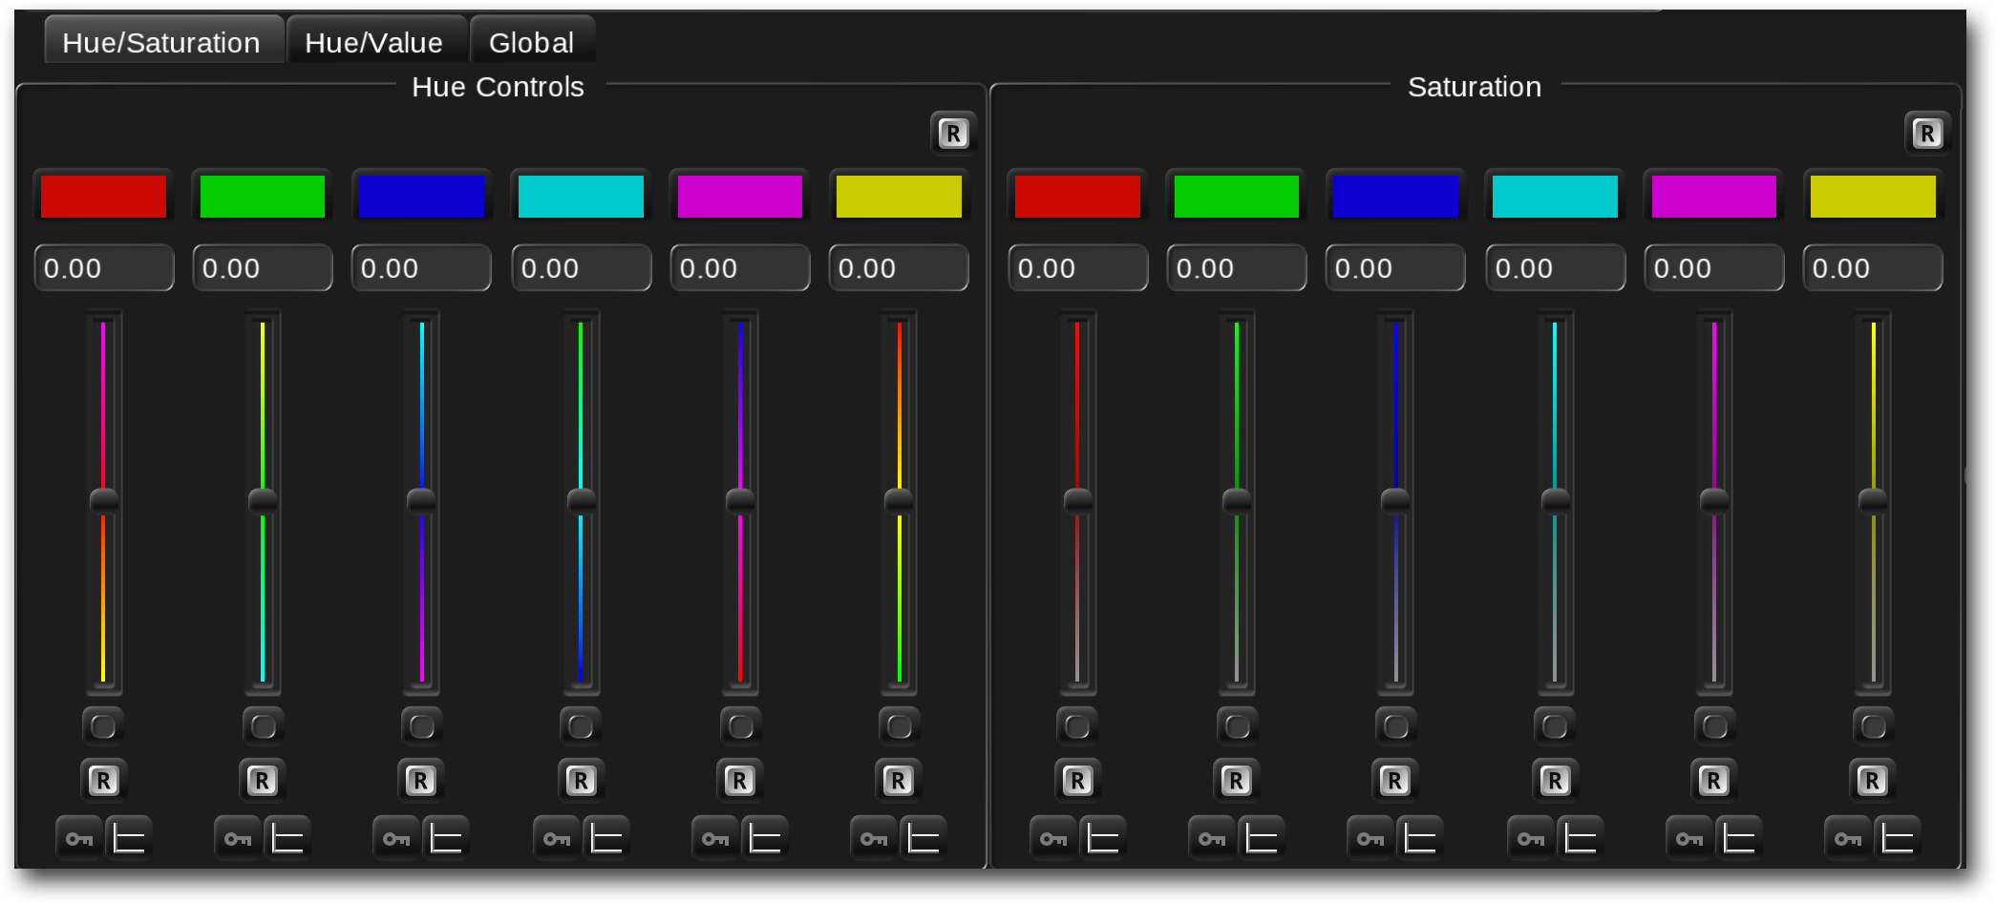

*Hue Shift operator – Hue/Saturation page selected*

1. Drag the cyan slider in the ‘Saturation’ section on the right-hand side up and down **→** The saturation of the cyan hues in the image will be reduced but all other colours will remain the same.
2. Select the **Hue/Value** tab and drag the cyan slider up and down **→** The ‘value’ or lightness of the cyan hues will vary.
3. On both pages there are **Hue vs. Hue** controls. Try adjusting one of them to see the affect that is has on the image **→** You will find that it changes the hues of only a certain range of hues in the image and has no effect on hues outside this range.
4. Note that there is also a **Global** page **→** This provides **Hue**, **Saturation** and **Value** controls which affect the whole image (these are not ‘selective’ grading operators):

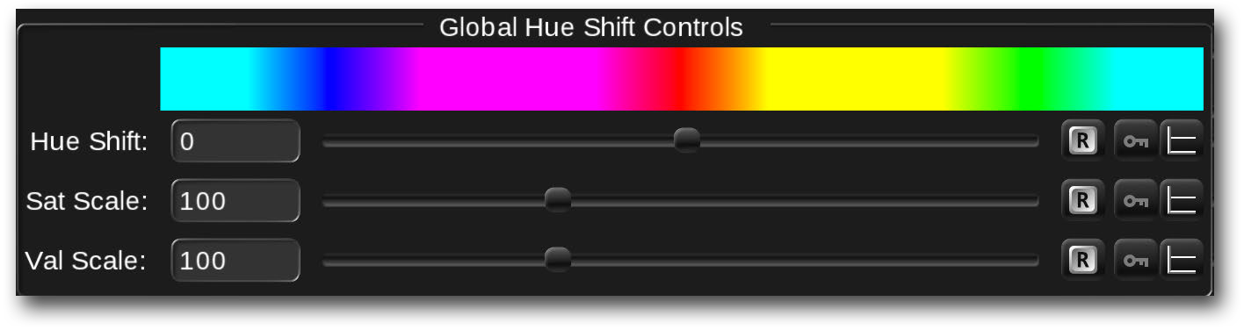

*Hue Shift operator – Global controls*

This is just one example of a grading operator which affects only a certain range of colours in an image. Baselight provides several other grade types such as HSL curves and Six Vector which can also be used for selective grading – these are covered in the Basic Grading chapter.

#### Inside/Outside grading using a matte

The previous section looked at a grading operator which inherently changes certain ranges of colour in the image while not affecting other colours. Another way to restrict the affect of a grade to certain ranges of hue or lightness is by creating a matte and then using that matte to isolate the affect of the grade to a certain area of the image. For example, using a chroma keyer we could create a matte from just the cyan hues in an image. In turn, that matte could be used to restrict where a grade is applied to desaturate the image. The following steps will take you through an example of this process:

1. Add a layer to one of the tutorial shots.
2. Press **H** on the keyboard **→** This will add an HSV or ‘**Hue Angle**’ keyer to the matte operator**s** for the layer. In the parameters view you will see the controls for the keyer and you will also notice that to its right are two columns of **Matte Operators** with the **HueAngle** keyer selected in the first column:

Qualifier controls

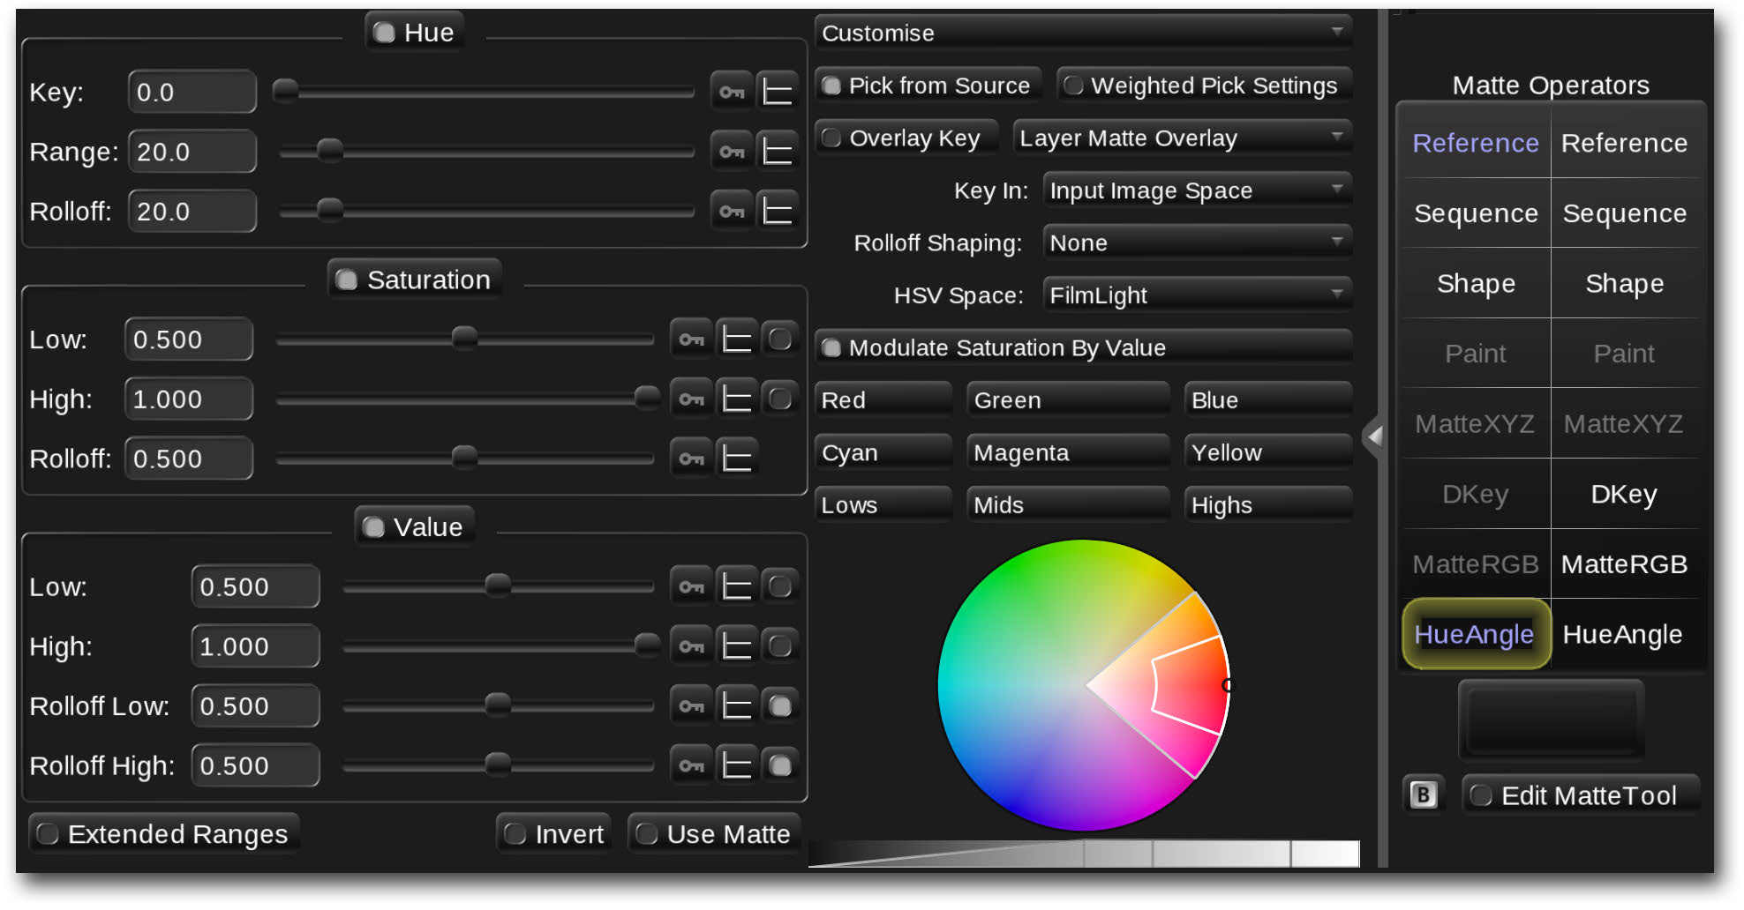

Preset

ranges

Colour

wheel

Greyscale

ramp

Matte tool

button

*Hue Angle keyer controls*

1. Move the mouse cursor over to the image display (press **CTRL+Esc** if working with a separate image display) and click-and-drag across a small range of colours in the image **→** The range of colours selected will set up the Hue, Saturation and Value qualifier controls. You will also see these indicated as a range in the colour wheel and on the greyscale ramp.
2. View the key matte you have just created by pressing **O** on the keyboard **→** The matte will appear in the image display as a monochrome image. White areas are those included by the qualifier settings; black areas fall outside the Hue, Saturation and Value qualifier ranges.

Baselight provides several different methods for showing and overlaying the matte for a layer. You can cycle through these by pressing **SHIFT+O** on the keyboard – for now, select the monochrome matte viewing mode.

Note that you can also preview the matte for a layer by double-clicking on the Cuts view thumbnail to bring up the Layer view – the matte is shown in the thumbnail to the right.

In the example below, an area of the sky was selected, creating a matte from the cyan/blue hues:

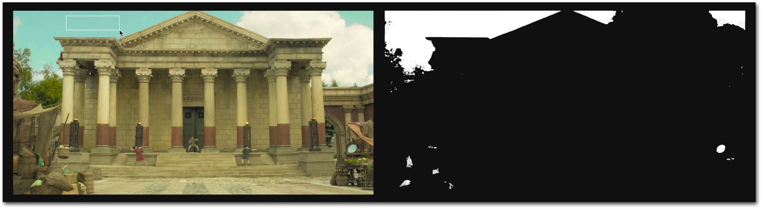

Source image Matte created from hues in sky

*HueAngle keyer example*

To zoom the image display so you can see more detail, hold down **CTRL** on the keyboard and then click-and-drag to the right using the *middle* mouse button; dragging left with the *middle* mouse button zooms out. Dragging with the middle mouse button but *without* holding down **CTRL** on the keyboard will pan the image display. To return to full screen mode press **F12** on the keyboard. Note that panning and zooming the image display using the middle mouse button has no effect on the final rendered images – it is only affecting the viewing display.

1. Now try adjusting the sliders in the Hue, Saturation and Value qualifier sections to refine the matte. Note that you can also make adjustments to the Hue, Saturation and Value ranges by clicking and dragging within the colour wheel and the greyscale ramp.

**→** Pressing **SHIFT+O** will cycle through the ‘overlay’ and ‘invert overlay’ matte viewing modes – these can help to see exactly which areas of the image the matte covers.

1. Once you have finished adjusting the matte, press **G** on the keyboard to return back to the grading operators for the layer.

**→** The controls for the selected grading operator will appear in the parameters view in place of the matte controls. Note that pressing **G** again will toggle back to the matte controls.



Clicking the ‘Mona Lisa’ buttons

above the operator columns will switch

between the grading and matte operators for the current layer. Note that hardware

control panels also provide buttons to directly select grading and matte operators.

You will notice that the second column of grading operators has become available (previously it was dimmed and unavailable) because this layer now includes a matte. The left column of operators will now only affect the parts of the image which lie *inside* the matte (i.e. where the matte is white) and grading operators in the right column will affect the area *outside* the matte (the black areas of the matte).

1. Select a grade type in the **inside** column – the Base Grade for example – and adjust its controls **→** Note that the grade is only applied to the areas which are qualified by the HueAngle keyer, in our example the *inside* grade would be restricted to the sky only.
2. Now click an operator in the outside column and adjust its controls. **→** This time only the areas *not* qualified by the key will be affected. Note that you can use different operators on the inside and outside of a matte allowing a complex look to be created within just a single layer.

In this example we isolated parts of the image with the HueAngle keyer, which uses an HSV qualifier to generate a matte. Baselight provides two other types of keyer and can also work with an external image matte, either read from an embedded channel within the input media file or from a separate input image layer. For full details of keyers and external mattes please refer to the Keyers and Mattes chapters later in this manual.

#### Grading through a shape

The previous steps took you through the process of creating a matte using a key. This is useful if you want to restrict the grade to areas depending on the content of the image. However, it is also possible to define areas in a matte using geometric shapes:

1. For this example, make sure you create a new layer on one of your shots before you start (press **P** on the keyboard). Then press **S →** A matte will be added to the new layer as in the

previous exercise, but this time the **Shape** operator will be selected, and the shape controls will appear in the parameters view:

New Shape mode

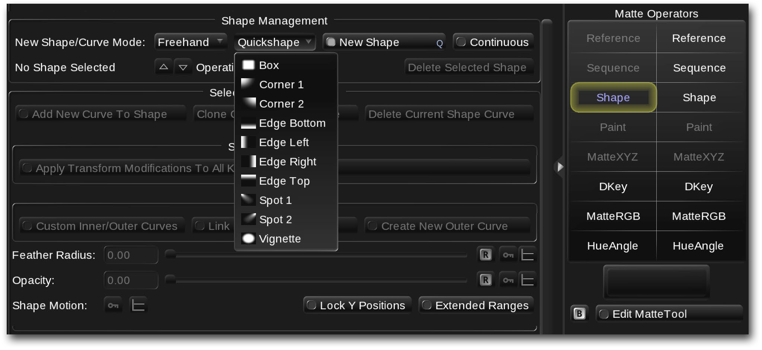

Quickshape drop-down

New Shape button

Shape operator

*Shape controls*

1. Click on the **Quickshape** button **→** A list of preset shapes will appear as shown above. For this example we will choose **vignette** – click on it in the list to add a shape to the matte.

**→** An overlay will appear on the image display showing the outline of an ellipse as a dashed yellow/blue line contained within a dim red rectangle. You will notice that there is also a blue rectangle enclosing the entire shape and various control points and handles:

Bézier curve outline

Bézier curve control point

Shape control point

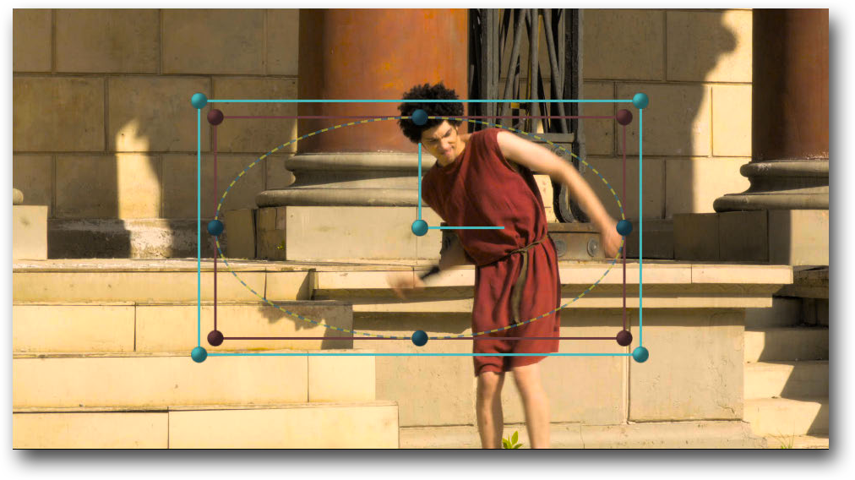

Bézier curve

bounding box

Shape control

handles

Shape

bounding box

*Shape overlay showing curve and shape controls*

Geometric shapes in Baselight are composed of one or more closed Bézier curves. If you add a preset ‘quickshape’ such as an ellipse or a rectangle, it will be created as a Bézier curve. The control points which define the curve can be adjusted using Bézier handles and points can also be added or removed from a curve. A red bounding box containing the curve can be used to scale and rotate the entire curve. An outer blue bounding box contains *all* the curves within the *shape* and can be used to transform the entire shape. Full details of creating and editing shapes are covered in the Shapes chapter on page 476.

1. Press **G** on the keyboard to return to the grading operators and then select an operator in the ‘**Outside**’ (right-hand) column of operators – for this exercise we’ll choose the **Film Grade**.
2. Reduce the Exposure control **→** The outside of the ellipse will darken, giving a typical vignette effect.
3. You will notice that the vignette effect has a soft edge; this is because the ellipse includes feathering. Press **O** on the keyboard to view the matte (if necessary, press **SHIFT+O** a few times to cycle through the matte viewing modes).
4. Press **G** again to toggle back to the matte operators and then adjust the **Feather Radius** slider in the shape controls to see the effect it has on the shape matte **→** You will notice that the feathering is always ‘outward’ from the curve outline.

By enabling the **Custom Inner/Outer Curves** mode toggle button, inwards feathering is possible, as well as variable feathering at different points around the curve.

1. Reduce the feathering to around 10 so you can see the edge of the shape and then click on one of the Bézier control points of the ellipse **→** A pair of Bézier handles will appear indicating that the point is now selected for editing. Try dragging on the point and also on the ends of its handles to see the effect it has on the curve.

Bézier curve outline

Selected control point

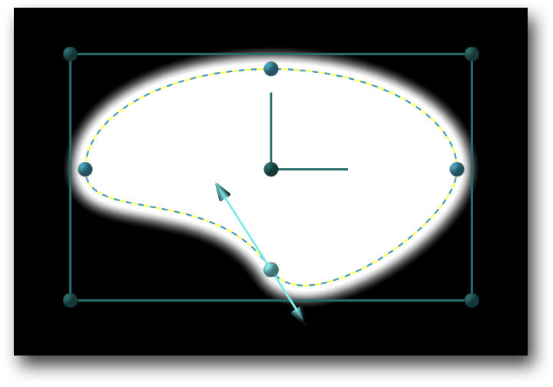

Bézier curve handles

*Bézier curve showing control point handles*

1. Click on the curve between two existing points **→** A new point will be added with its handles set so that there is no change to the shape of the curve. You can now adjust this new point.
2. If you would like to return to the original vignette, simply press **CTRL+Z** a few times to undo all the changes you made to the shape.

This is just a very brief overview of using a shape operator to create a matte. In addition to using Quickshapes, shapes can also be created starting with a ‘primitive’ ellipse or rectangle, or by drawing points using the freehand option. The transparency of individual shapes and also the way multiple shapes combine together within the matte can be adjusted. Full details of shapes can be found in the Shapes chapter and also in video tutorials on our website.

Quick Start

Working with audio

Scene audio

## Working with audio

You may need to add sound to a Baselight scene for a couple of different reasons. Firstly, if you are working on a scene which has been edited and conformed then a sound track may be available which can be added to the scene to play back as a preview. The second reason is adding sound to the source shots in your scene.

In this quick start guide we will briefly cover both scenarios – please see the Working with Audio chapter for more details.

#### Scene audio

To add audio which will play back throughout the scene:

1. Open **Scene Settings** from the **Views** menu at the top of the screen and select the

**Scene Audio** page by clicking on the tab.

1. Click on the **Type** button and choose **File or Movie →** Additional options will appear.
2. Click on the file browser button  at the right-hand end of the **Filename** field and browse to find the audio file you want to play back with the scene. Select the file by clicking on it and then click on the **Ok** button **→** The path to the selected audio file will now appear in the **Filename** field.

Note that Baselight currently only supports playback of uncompressed audio file formats such as WAV and AIFF. You can also use a movie containing an audio track.

1. If there is a time offset between the start of the audio and the first shot in the scene, you can compensate for this by entering a number of frames or seconds into the **Offset** field (switch between frames and seconds by clicking on the ‘**S**’ or ‘**F**’ button). Note that a *negative* offset will start the sound playing by that amount of time *after* the beginning of the scene.
2. The **Ratio** button allows for the audio to be sped up or slowed down by a small amount if it was recorded using a different ‘time base’ to the scene’s playback frame rate. For example, if the audio was recorded with a timebase (i.e. timecode frame rate) of 23.976fps but the scene has a working frame rate of 24fps, you should set this to 1000:1001. Note that as the audio will be running at a different rate to when it was recorded, the pitch will be shifted slightly.
3. The last two options provide adjustment of the audio level and the playback channels.

#### Shot audio

Audio can also be added to each shot in the scene. If a shot was imported as a movie file which contained an audio track then the audio will already have been added to the shot by default. However, it is also possible to manually add audio to a shot:

1. Select the Standard workspace and select the input layer for the shot (you can do this by selecting the top layer in the Layer Manager).
2. Click on Audio in the layer 0 operators column:

Layer manager button

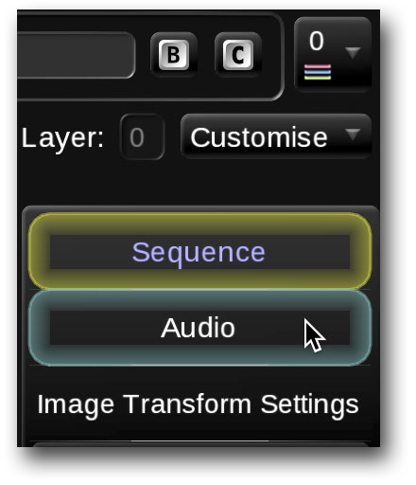

Audio selector

*Input layer (Layer 0) ‘operators’*

**→** The audio settings for the current shot will appear in the parameters area. If there is currently no audio, the audio **Type** drop-down button will be set to **No Audio**.

1. To add audio to the shot, click on the **Type** button and choose **File or Movie →** Additional options will appear. The next steps are the same as for adding audio to the whole scene – see steps 3 to 6 on page 37.

**→** Once the audio file has been added to the shot it will play back for the duration of the shot. Note however that if you have added audio to the whole scene, this will override any audio which exists for individual shots.

There are other options for per-shot audio which can be used to help automatically find and synchronise audio to one or more shots. These features are covered in detail in the Working with Audio chapter of this user guide.

## Rendering and export

Once you have finished grading and reviewing your scene, the final step is to export it. However, before continuing you should make sure that the scene is saved. The quickest way to save the scene is to press **CTRL+S** on the keyboard. You can also select **Save** from the **Scene** menu at the top of the screen.

Baselight automatically saves every change you make into the database so the scene is effectively being continually saved as you go along. This is useful in the case of sudden power loss or a system crash. However, when you actively save the scene, this ensures that the latest changes are fully written to the database and also creates a ‘last saved’ time stamp.

#### Rendering movies and sequences

Media files can be rendered either as movies or frame sequences. In both cases you can either render the entire scene as a single movie or frame sequence, or you can render a movie (or sequence) per shot. In the latter case there are several options on how to name each separate movie or frame sequence.

To render the entire scene as a single movie or frame sequence:

1. Open the **Render** view from the **Views** menu or press **WIN+R** on the keyboard.

**→** The Render view will appear as shown on page 40 – it contains a lot of information. If necessary drag on the edges of the view to resize it.

At the very top of the **Render** view you select the frames you want to render by clicking on the **Frames To Render** button. By default this is set to **All Frames** which will render every frame in the scene from the first frame of the first shot to the last frame of the last shot. To select a different range of frames or multiple frame ranges click on the button and then select the required frame range(s) from the drop-down options. You can also type in the required frame range(s) by typing them in to the field to the right of the button.



Below the frame range setting you will see a row of tabs – these tabs provide two functions: clicking on a tab will select a render settings page containing all the settings for a specific type of deliverable; enabling the white toggle button in a tab will activate that deliverable for rendering. Note that multiple deliverable tabs can be enabled in which case multiple deliverables will be rendered at the same time. Please see the Rendering & Deliverables chapter for further details.

1. If you have been following this guide from the start, then the deliverable tabs in the render view will have been automatically preset from the ‘FilmLight’ template used to create the

scene. Click on the ‘QT for Approval’ tab to select its settings and also click to enable its white toggle button. Make sure that the buttons in all other tabs are turned off:

Render frame

range selector Deliverable tabs

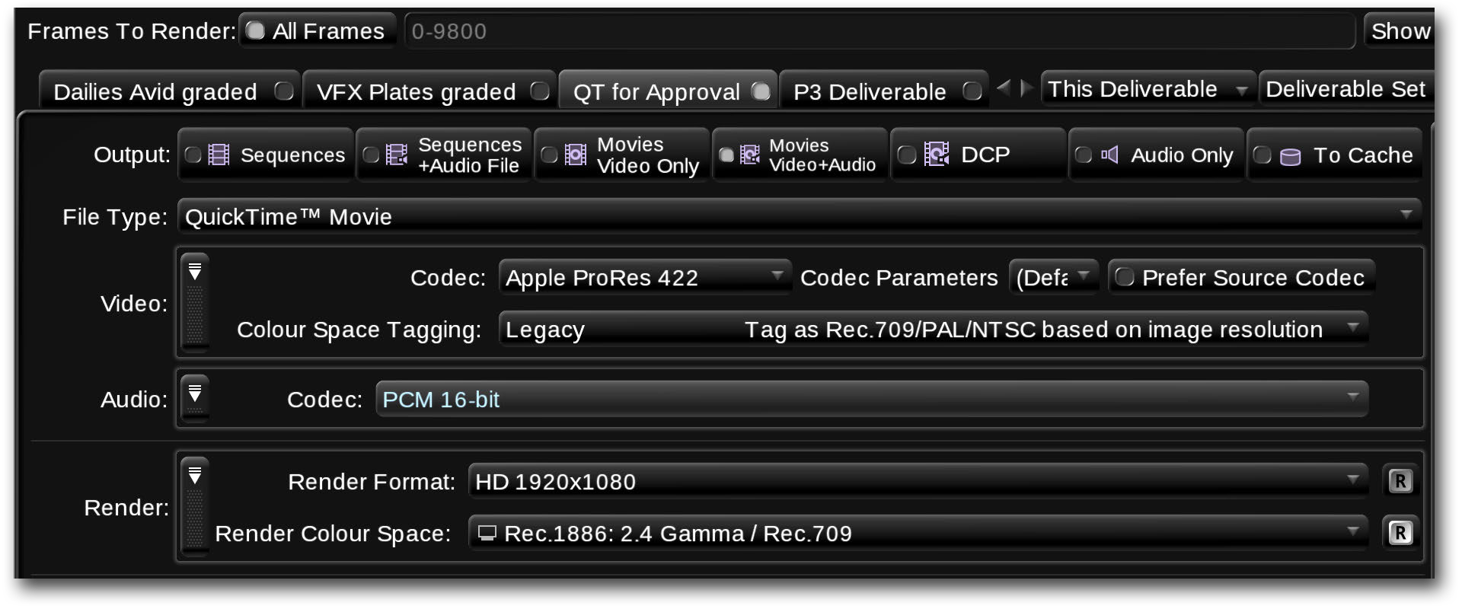

*Render view with first deliverable tab selected and enabled*

1. If you want to change the name on the tab, double click on it and then type in the new name

**→** It is useful to use a name which describes the ‘purpose’ of the deliverable, for example you may want to label it “Full Scene Review”.

The rest of the steps go through the process of checking and changing the render settings. As this is just a quick overview many of the options will be skipped, please refer to the Rendering & Deliverables chapter for full details.

1. Select the type of output media by clicking on the appropriate **Output** button. Note that you can choose to render to a movie format such as QuickTime or MXF, or a frame sequence (DPX or EXR for example). Audio can also be rendered with the deliverable.

For this exercise choose **Movies Video+Audio**.

1. Next, click on the **File Type** button and choose **QuickTime™ Movie** from the drop-down list.
2. Once you have chosen the file type you can then choose the type of encoding to use for the movie by clicking on the **Codec** button in the **Video** settings and selecting from the drop- down list.

Note that the STUDENT version of Baselight only supports a limited range of output options.

**→** Leave the rest of the **Video** and **Audio** settings set as they are for now and move down to the **Render** section. There are several settings in this section – we will just look at a couple in this exercise:

1. The first setting is the **Render Format**. This setting may initially be hidden – to make the option visible it needs to be added by clicking on the **add options** button  and then selecting **Render Format** from the list of available settings.



Settings which are currently set to their default value are normally hidden from ‘options’ menus to simplify the user interface. If you want to reveal *all* the settings which are set to their default values, select **Add All** from the **add options** list (click on the button). To re-hide a setting which is set to its default value, hover the mouse pointer over the setting name **→** When a red line appears through the text, click on the text to hide the setting. There is also a **Remove All** option in the **add options** list.

1. By default, the **Render Format** will be set to match the **Working Format** – in this case HD 1920x1080. If you want to render to a different resolution you can choose the appropriate format from the drop down list by clicking on the **Render Format** button. Note that this list will only include the built-in ‘factory’ formats and custom formats which have already been defined and made available to the scene. Please refer to the Formats chapter for further details.
2. The second option to add is the **Render Colour Space**. Again, the default setting for this is to match the **Working Colour Space**. However, you should always check this and change it to match the required colour space of your deliverable. For example, if you are rendering a movie to be played back on a standard HD monitor then you would choose the **Rec.1886:2.4 Gamma/Rec.709** setting.

Note that in this example the **Render Colour Space** setting will probably already be visible as the setting will have been set to **Rec.1886:2.4 Gamma/Rec.709** by the scene template. This is *not* the default value as it does not match the example scene’s *Working* colour space.

The final steps are to select the output directory and the file name of the rendered movie. Baselight provides a powerful template system which can incorporate system variables to automatically create directory paths and file names according to various criteria. However, in this example we will manually specify the output path, destination directory and file name:

1. Make sure that the **Directory** and **File Name** settings sections are visible – if necessary click on the **Show output template** button:

Show output

template Output directory browser

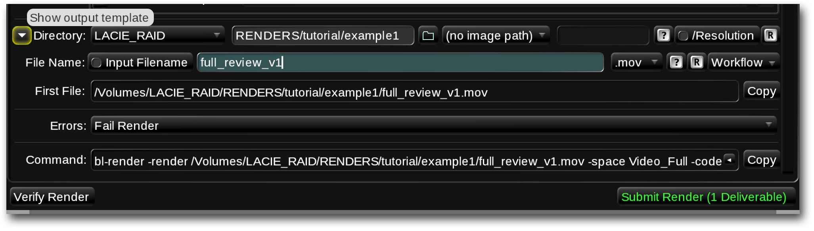

Resolution directory toggle button

*Render directory and file name settings*

1. Click on the directory browser button  and navigate to the destination volume and directory into which you want to save the rendered movie file.
2. Enter the file name for the movie (without the file extension) into the text field to the right of the **Input Filename** button. Note that this field may already contain a preset name or file name template consisting of one or more ‘%’ codes. In this case, simply triple-click in the field, or click and then drag over the existing text to replace it. The drop-down button to the right of this field allows you to choose an appropriate file extension for the chosen type of output.

**→** The **First File** field will now show you the full directory path and file name of the output deliverable. Note that it will probably include a ‘1920x1080’ directory before the file name. This ‘resolution’ directory indicates the resolution of the media file(s) it contains and can be very useful for certain types of workflow. If you don’t want Baselight to automatically generate the resolution directory, turn off the **/Resolution** toggle button at the right-hand end of the **Directory** settings.

There are several other options in the render settings which we have not covered but these can be left as they are not used for the purposes of this exercise.

1. You will notice that there are two buttons at the bottom of the **Render** view: **Verify Render** and **Submit Render**. Click on the **Verify Render** button **→** Baselight will scan through the source material to check that the required frames are available. Once the scan is complete you should see a message saying that the frames should render correctly.
2. Finally, click on the **Submit Render** button at the bottom right corner of the Render view. When prompted, enter a title for the render operation (or accept the default title) and click on **Submit**.

**→** The render will be submitted to the render queue and the **Queue Monitor** window will automatically open.

If you are working in a networked environment with multiple Baselight systems you will be able to choose which machine you want to submit the render to, including the local machine.

**→** The **Queue Monitor** will show the progress of rendering operations on the selected machine. To see more information about an operation, select it in the list – details will appear in the log area at the bottom of the Queue monitor view.

Current rendering operation

Rendering progress

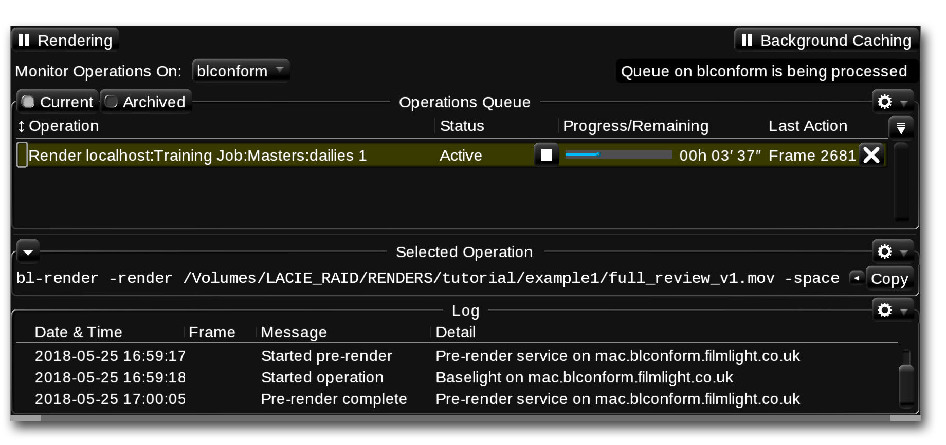

*Render Monitor showing rendering operation in progress*

**→** Once the rendering operation is complete you will be able to check the rendered movie using the **Preview** and **Play** buttons in **FLUX Manage** (see page 151).

In this example we created a *single* movie from all the shots in the scene. In many workflows, such as VFX or dailies grading, you would typically want to render a *separate* output movie (or frame sequence) for each input shot. Please refer to Chapter 35 – Rendering & Deliverables for full details.

## Quitting Baselight

Now that you have completed the basic steps in an end-to-end workflow you can save your project and quit out of the application.

To do this you can simply click the **Baselight** drop-down in the top left of the UI and select **Exit**. This will close the software. You can also use the keyboard shortcut **Ctrl+Q**.

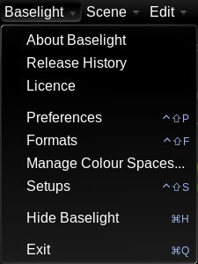

*Exit Baselight option drop-down*

An additional dialogue window will open upon clicking this option if you have any unsaved changes to give you a chance to save before the software closes. You can choose to **Save** and exit, **Discard** the changes made since the last save and exit or to **Cancel** the software shutdown and go back to the UI.

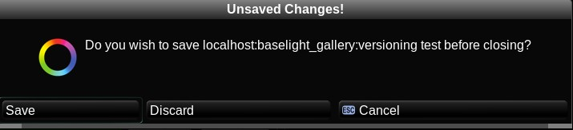

*Unsaved changes dialogue window*



# Chapter 3 Setup

This chapter covers the following topics:

Overview

System setup The Setups Editor Preferences

47

47

48

51

Baselight is a complex system with several hardware and software components which all need to be set up correctly to ensure that your projects run smoothly and give you the best quality results.

This chapter covers the setup of the different hardware and software parts of the system

## Overview

[Configuration of the Baselight system is carried out at different ‘levels’. Firstly, there is the initial setup, or installation – this is normally carried out when the system is first installed, typically by a FilmLight engineer. It involves the physical mounting of the system hardware as well as the integration with other systems such as networks used for remote access and shared storage. This level of setup isn’t covered in this manual but](https://www.filmlight.ltd.uk/support/documents/baselight/manuals_bl.php) [details are available in the](https://www.filmlight.ltd.uk/support/documents/baselight/manuals_bl.php) Installation Manual for your system and the [Baselight Technical Manual](https://www.filmlight.ltd.uk/support/documents/baselight/manuals_bl.php).

The next level of setup is the configuration of the system hardware and related software settings which affect the overall operation of the machine. Then there are two further ‘levels’ of setup - ‘user’ settings, which allow each different user to customise certain parts of the system, and ‘scene’ settings which are specific settings unique to each scene within a job or project. The following sections of this chapter cover these three levels: system setup, user settings and scene settings.

## System setup

Before you start working on a job in Baselight, the system must be correctly setup up according to the chosen workflow. Typical steps in the setup procedure are:

1. Set the grading display to the required resolution, frame rate and colour space.
2. Choose the default working resolution, frame rate and colour space
3. Set the required cache format and bit depth
4. specify the default media path – this is also known as the default image container
5. Check and modify other default settings such as timecode rate, image transform filtering,

All of these steps are carried out by making changes in the **Baselight Setups Editor**; each combination of settings can then be saved as a ‘workflow’ preset as described below.

Baselight ships with several preset ‘setups’ which cover most typical professional colour workflows. They are primarily based on the settings of the master grading display and have names which reflect this such as

“**2k 24p (DCI)**” and “**HD 25p (422)**” however, there are many other parameters which make up the ‘setup’ so it is a good idea to create your own setups with names which describe the workflow rather than simply the primary display settings.

## The Setups Editor

The Baselight Setups Editor is a utility program which can either be run from within the Baselight application or as a standalone utility. If the Baselight application is currently running, you can open the **Setups Editor** by selecting **Setups** from the main **Baselight** menu at the top left corner of main UI screen; you can also use the keyboard shortcut **WIN+SHIFT+S** (or **CTRL+SHIFT+S** on a mac).

The standalone utility can be launched using the ‘bl-setups’ icon: This is located either on the desktop of a Linux system or in the Applications folder on a Mac.

The **Setups** utility will open in a separate window showing a list of the current preset setups – the example below shows part of the standard list of factory setups:

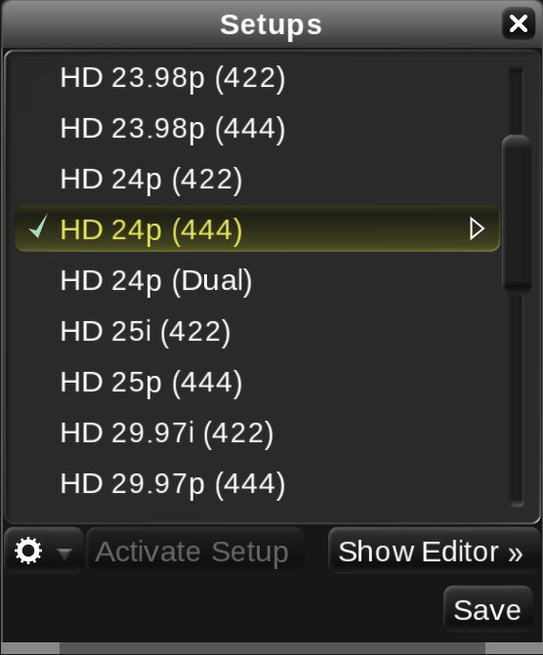

*Baselight Setups utility showing list of preset setups*

The currently selected setup is shown with a green check mark. To select another preset, simply click on it to highlight it in the list and then click on the **Activate Setup** button which will turn green to indicate it is available.

Each setup will configure Baselight for a specific kind of workflow as mentioned above. Activating a specific setup will apply the following settings:

**Primary video output →** Sets the interface type and mode for the primary grading display (SDI/HDMI/DVI or none if you are working on a single-screen platform such as a macbook); Resolution; Frame rate; Field mode (Progressive/Interlaced/PsF); Full/Legal range video scaling.

**Viewing settings →** The colour space of the grading display; any applied display LUT (Truelight).

**Audio monitoring hardware →** Systems which include an SDI output have the option of embedding the audio within the SDI signal. Alternatively, other audio output hardware may be available (please refer to the installation manual for your system).

**On-screen counter settings →** Default settings for various counters which can be displayed as an overlay on the grading display (see page 279).

**Default settings for new scenes →** When a new scene is created without using a template, settings from this section will be used as defaults for the new scene.

The preset you select should configure the system with appropriate settings for the type of grading display – for example if you are working on a Baselight ONE, grading HD dailies for a TV series you might connect an HD resolution SDI monitor to the system set to 25fps, progressive scan with a colour space of Rec.709. You would then choose a preset Baselight Setup which configures the video output and viewing settings accordingly.

Normally, any modifications to setups and additional setups would added during the installation of the system and saved with an appropriate name, however, it is a good idea to check the settings you are about to use by clicking on the **Show Editor** button at the bottom of the **Setups** window.

The following steps explain how to create a new setup and then edit its settings for a specific type of workflow:

1. Click on an existing setup in the list which has some common settings to the ones you require for your workflow. Note that you can actually base your new setup on any existing setup, however starting with one which already has the basic settings required for your workflow will mean there will be fewer things you need to change.
2. Select the **Duplicate Setup** option from the Actions drop-down menu button: 
3. Enter a suitable name for the new setup and then click on the **Ok** button.
4. Click on the **Show Editor** button **→** the Setups Editor window will now expand to show several different tabbed pages of settings:

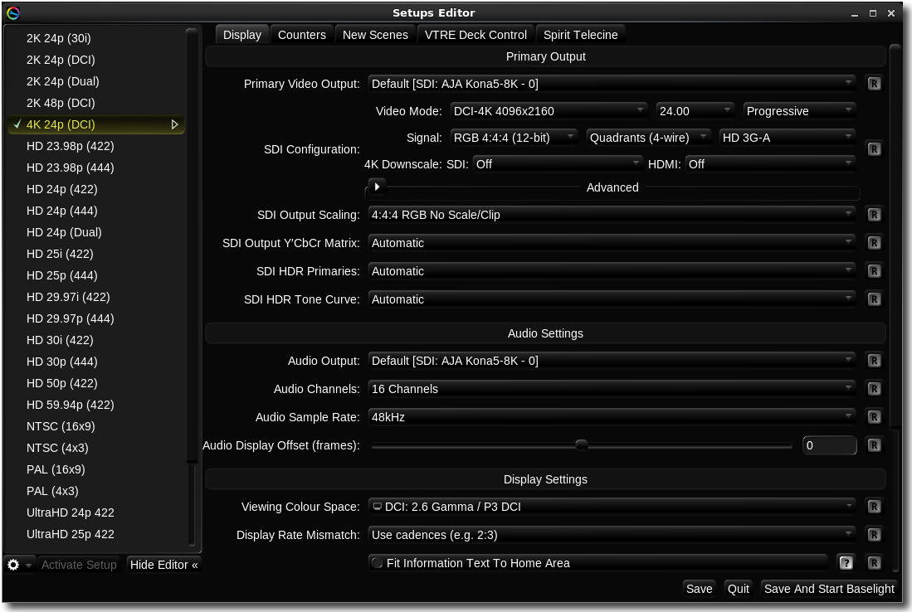

*Editor pages of the Baselight Setups utility*

The settings we are concerned about for configuring Baselight for a specific workflow are contained on the **Display** and **New Scenes** tabs. Other tabs will provide access to additional system settings but these are not part of the workflow setup and are not covered in this manual – please refer to the *Installation Manual* for your system for full details of creating a new setup.

#### Display tab

Clicking on the **Display** tab accesses the settings related to the main image display – that is the display used for grading. The various menu options are described below.

Note that the drop-down menus for some of the settings will vary depending on the platform and the hardware options installed in your Baselight system.

**Primary Video Output →** This would normally be set during the system installation according to the connection to the main grading display; unless you change to a different type of display you wouldn’t need to change this for a specific workflow. The subsequent options will vary depending on the type of hardware but should be set to match the settings for your display in terms of resolution, frame rate and frame mode.

#### Counters tab

Default settings for various counters which can be displayed per-cursor as an overlay on the main grading image output. There are also two sliders on this page which set the relative height of the characters used to display the counters and also their intensity.

#### New Scenes tab

This page defines default settings for many of the parameters you will find in the **Scene Settings** view (see page 101 in the Jobs & Scenes chapter). These settings will be used for new scenes which are created without using a template. They are grouped into the following sections:

**General →** Various settings which define default values for items in the **General** page of the

**Scene Settings** view.

**Format & Colour →** Default settings for the working format, frame rate, working colour space, Display Rendering Transform, other colour spaces which will be used within the scene pipeline and defaults for the mastering colour space.

**Stereo →** Default setting for the stereo 3D mode of a new scene.

**Default Image Transform →** Sets the defaults for this page in the **Scene Settings** view.

**Image Containers & Proxies →** Sets the default image containers for the high, medium and low res proxies (see page 285 for more details).

#### VTRE Deck Control tab

(Only available on systems which include VTR machine control hardware) – This page includes settings for the video input/output mode of the VTR deck, timecode settings, sync options and machine control settings.

#### Spirit Telecine

(Only available on systems which include the Spirit Telecine control option) – This page includes settings for the video format of the telecine system, timecode source, control timing and keycode reader.

## Preferences

Baselight preferences are used to customise specific tools and operational aspects of the system. They can be applied at three different ‘levels’:

* **Site-wide** – settings which are applied to all systems in an organisation. For example, default template settings or the location of centralised resources such as a global formats database.
* **Local machine** – these are settings which would apply to all users of the local machine or ‘host’. Each different machine may have different settings, for example the media cache location and settings.
* **User settings** – each user has their own preferences file which allows individual customisation of most of the tools in Baselight, such as the sensitivity of the grading controls or the default keyer mode.

Setup

Preferences

Editing Preferences

These three levels are hierarchical such that a user preference for a specific setting will override the local machine preference for that setting, which will in turn override any site preference which may have been set. In practical terms, when the application first starts up, it first loads any site settings from a central file, it then loads settings from the local host preferences file (overwriting any which may have already been set from the site-wide preferences) and then finally, the user preferences are overlaid as illustrated graphically below:

AƉƉůŝĐĂƟŽŶ ŽĨ ^ĞƫŶŐƐ



&ĂĐƚŽƌǇ ^ĞƫŶŐƐ

^ŝƚĞ WƌĞĨĞƌĞŶĐĞƐ

,ŽƐƚ WƌĞĨĞƌĞŶĐĞƐ hƐĞƌ WƌĞĨĞƌĞŶĐĞƐ

CŽŵďŝŶĞĚ WƌĞĨĞƌĞŶĐĞƐ



*Preferences hierarchy*

Note that settings which are not applied from any of the preference levels will revert to an internal default ‘factory’ setting. In most cases this is the same setting as when you press the  reset button next to a specific setting in the Preferences Editor (see below).

#### Editing Preferences

Preferences are modified using the **Baselight Preferences Editor**. This can be opened either as a stand-alone utility application or from the **Baselight** menu at the top left corner of the UI screen. You can also open the **Preferences** editor using the keyboard shortcut **WIN+SHIFT+P** from within the Baselight application.

Setup

Preferences

Baselight preferences

To launch the Preferences editor as a stand-alone application, double-click on the  icon which can be found on the Linux desktop. The preferences editor window will open as shown in the example below:

Reset setting to default value

Preference search

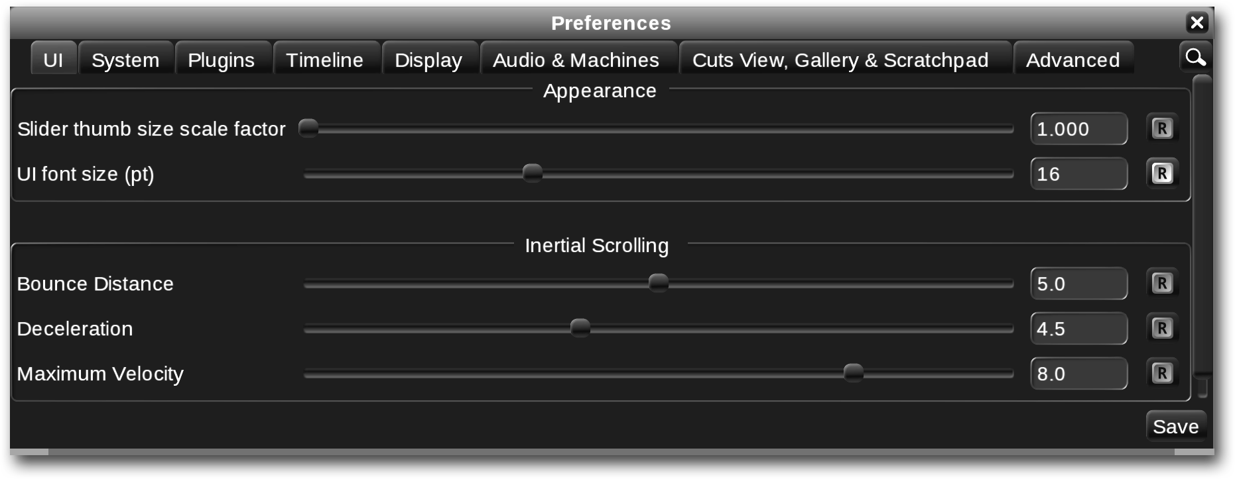

*Baselight Preferences settings*

Preference settings are grouped into tabbed pages, each relating to a specific area of the system. The pages are summarised below; detailed explanations and guidance on setting these preferences are provided in the relevant sections of this user guide.



To find a particular preference setting, click on the preference search button

the top right corner of the Preferences view.

at

#### Baselight preferences

**UI →** Controls to adjust the appearance of the UI, for example the scaling of fonts and controls within the user interface.

**System →** Settings which affect the operation of the system including the global formats database, caching, hardware control surfaces, BLG export defaults and DCP encryption.

**Plugins →** Various settings which apply default values and modify the operation of grades and other operators within the Baselight grade stack. Note that the term ‘plugin’ here does not refer to 3rd party plugins but the *internal* operators which are built into Baselight.

Setup

Preferences

Setting Site and Host Preferences

**Timeline →** Settings related to the appearance of the timeline and navigation within the Baselight scene. This page also has settings for modifying categories, selection modes and copy/paste operations.

**Display →** Default settings and controls which affect the way the image appears on the grading display.

**Audio & Machines →** Audio related settings such as waveform colour and default monitoring volume, plus settings for systems which include VTR deck or telecine control.

**Cuts View, Gallery & Scratchpad →** These settings control the default behaviour, operation and appearance of the Cuts View, Galleries and Scratchpad, and also the thumbnails they contain.

**Advanced →** Advanced system settings such as debug logging and enabling the upgrade of ‘legacy’ scenes created using older versions of the software.

#### Setting Site and Host Preferences

As mentioned above, certain default settings can be set for all users of a specific Baselight system, or for all users on all systems within a site. To modify settings at the host or site level the same preferences editor is used, however it must be run from a command-line prompt in order to update the appropriate settings file.

The commands are:

**bl-prefs -site →** To access and edit the site preferences

**bl-prefs -host →** To access and edit the host preferences.

Note that running **bl-prefs** without an argument will edit the current user’s preferences in the same way as launching the utility using the icon or from within the Baselight system.

Further details of configuring site and host preferences can be found in the System Administration chapter of the Baselight Technical Manual.



# Chapter 4 UI & Workspaces

This chapter covers the Baselight graphical user interface and on-screen controls. For details of hardware controls and displays found on the Slate and Blackboard grading control surfaces, please refer to the appropriate User Guide for your control panel.

The following topics are covered:

Overview

Customising workspaces

Main Menu and Status Information The Parameters view

On-screen controls

Zooming and panning in the user interface Thumbnails

Selection Methods Other User Interface Tools

Directory and File browsers

57

58

63

65

71

78

80

81

83

85

## Overview

The Baselight graphical user interface consists of a ‘workspace’ containing several docked ‘views’ which are displayed across one or more ‘UI monitors’:

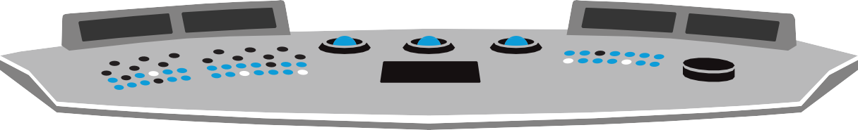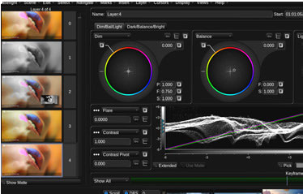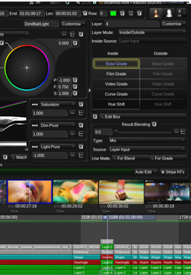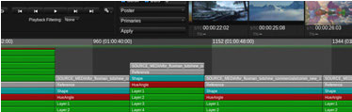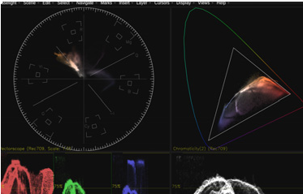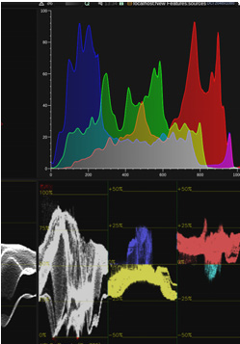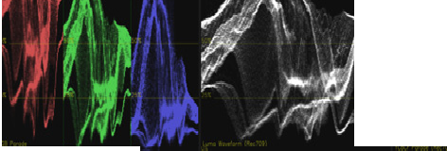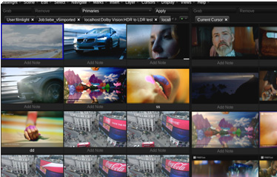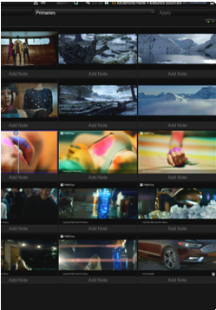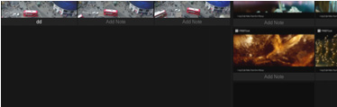

*Baselight workspace spread across three UI monitors*

A ‘view’ contains controls and parameters relating to a specific area of Baselight functionality, for example the **Cursors** view contains controls relating to the Baselight cursors. Certain views may display different content depending on the current selection or operational context – for example, the **Parameters** view will show controls and parameters for the currently selected image sequence or operator, depending on the current active selection (see page 65).

Like any other computer application based on a graphical user interface, we use specific terms to refer to the different controls, displays and data fields found in the UI. Please note that the terminology we have developed applies to the unique controls found within the Baselight user interface and may be different from terms you are familiar with from other systems. For consistency and to gain a full understanding of the Baselight user interface paradigm, you are encouraged to learn the terms we employ in this manual and throughout all other FilmLight documentation and resources.

Some views include different areas or groups of related controls, these are sometimes referred to as a ‘**panel**’. This term can also refer to a view which contains just a single set of related controls, such as the **Colour Panel** (see page 83).

UI & Workspaces

Customising workspaces

The Image display

#### The Image display

To distinguish the display used for grading from the displays used for the graphical UI, we refer to the main grading display as the ‘Image Display’ or the ‘Grading Display’. In most Baselight installations the image display is a calibrated reference monitor or digital projector designed to provide accurate and repeatable results within a controlled environment. On systems which are not being used for critical colour decisions, for example assist or Baselight CONFORM workstations used for media preparation and other non-grading tasks, it is acceptable to use a lower grade display or even a standard computer monitor. Some systems may even provide the Image display as a window within the UI workspace rather than as a separate dedicated display

– note that in the latter case, the display will be limited to a colour depth of 8 bits and typically an sRGB colour space.

Where an external reference display is used, this is connected to the system via an SDI or HDMI interface – full details of monitor connections and configurations can be found in the Installation Manual for your system.

Full details of the image display are covered in the Playback & Cursors chapter – see page 262.

## Customising workspaces

Each user can create any number of customised workspaces by adding, removing and arranging the views. The whole UI can be switched to any of the user’s saved workspaces at any point – the first nine can be assigned to keyboard shortcuts for quick switching without needing to select them from a menu.

Within each workspace, views can be moved to the most convenient location on the screen or hidden.

A few ‘factory preset’ workspaces are included which provide a convenient set of views for different screen layouts or stages of a typical workflow:

* Standard
* Simple
* Large Cut View
* Large Gallery
* Audio

These workspaces are fixed and cannot be edited. However, they can be used as a starting point to make new, user-customised workspaces as described below.

UI & Workspaces

Customising workspaces

Creating a new workspace

#### Creating a new workspace

To create a new workspace, first switch to the workspace that you want to base the new workspace on by selecting it from the **Views** menu at the top of the screen. You can also use the **WIN+[0~9]** keyboard shortcuts to select workspaces – see Workspace shortcuts on page 62 for more details.

It is a good idea when customising an existing user workspace to first create a new workspace – if you find that you do not like the new layout you can then easily revert to your previous workspace. There is no undo for changes made to workspaces

Create the new workspace by pressing **WIN+SHIFT+N** on the keyboard, or selecting **New Workspace** from the **Views** menu **→** This duplicates the current workspace and gives it a label of **Workspace (N)** where **N** is the next available workspace number. Note that you can alter this label in the **Manage Workspaces** window (see page 61).

UI & Workspaces

Customising workspaces

Hiding, inserting and moving views

You can now customise this workspace by showing or hiding views and moving the views to different positions within the layout. The example below shows a workspace within a single UI monitor containing several docked views plus a the Job Manager view in a floating window:

Parameters view Splitter bar Docked scopes

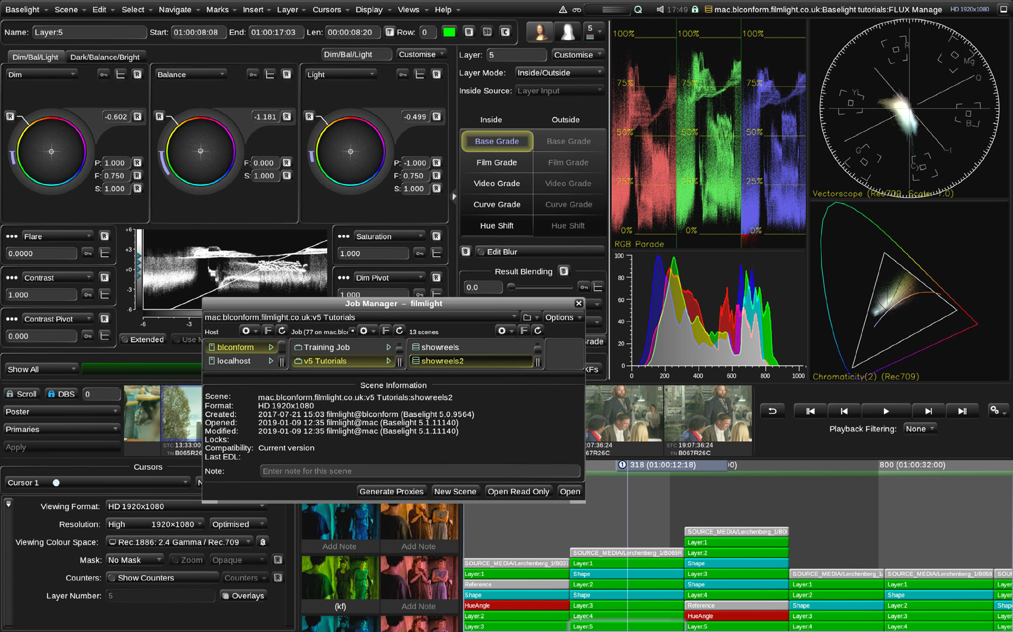

Cursors view

Floating window Cursor Cuts view

Timeline

*Baselight Workspace example (single UI monitor)*

#### Hiding, inserting and moving views

Most views can be inserted into a workspace from the right-click menu that becomes available when you hold down the **WIN** key. If a view is already visible in a different part of the workspace, it will be moved from its existing location to the new position.

To hide, insert and move views within a workspace:

1. Hold down the **WIN** key on the keyboard and right-click the area of the user interface where you want to hide an existing view, or insert a new one.

UI & Workspaces

Customising workspaces

Floating views within a workspace

1. To hide the view you clicked on, select **Hide <view>**, where **<view>** is the name of the view you clicked on. When a view is hidden, it will be removed from the workspace and the adjacent views will automatically be re-arranged and scaled to fill the gap left.
2. To insert a new view, select it from the **Insert** pop-up menu.
3. To move a view which is already in the workspace, hold down the **WIN** key and left-click and drag the view to the new position **→** the view will drop into place when you release the mouse button, re-arranging and scaling the adjacent views to accommodate it.

Note that view cannot span across two monitors. Also, it is not possible to drag a view from one UI monitor to another – if you want to move a view to another monitor you will need to hide it on the first monitor and then insert it into the workspace on the second monitor.

1. Views can be manually re-sized by left-clicking and dragging on the ‘splitter bars’ which separate them (see example on page 60).
2. If you want to prevent a view from being re-sized, then it’s height and/or width can be locked by holding down the **WIN** key which right-clicking on the view and then select either **Lock Width** or **Lock Height** from the pop-up menu. To temporarily override a locked view, you can hold the **CTRL** key while clicking and dragging on the splitter bars.

Note that a single workspace spans across all UI monitors, so switching to a different workspace will change the views shown in each monitor. If you want the same views to appear in the same place for multiple workspaces they will need to be set in the appropriate monitor when defining each workspace.

#### Floating views within a workspace

As well as being inserted into the workspace, some views can also be ‘floated’ so that they sit in front of the main user interface. Note that not all views can be floated in this way – generally, the views that can be floated are those that can be opened as standalone windows from the **Views** menu, for example the

Job Manager, as in the example on page 60.

To float a view which is already in the current workspace, right-click on the view while holding down the **WIN**

key on the keyboard. Then select **Float <view>** from the pop-up menu, where **<view>** is the name of the view.

Floating views remember their size and position when they are closed and reopened, and when Baselight is restarted.

#### Managing workspaces

The **Manage Workspaces** window displays a list of the available workspaces and allows you to quickly switch between workspaces, create new workspaces, and rename or delete them. It also allows you to select the workspace that should be displayed when Baselight starts up.

To open the Manage Workspaces window, press **WIN+SHIFT+W** on the keyboard, or select **Views > Manage Workspaces** from the main Baselight menu.

Workspace name

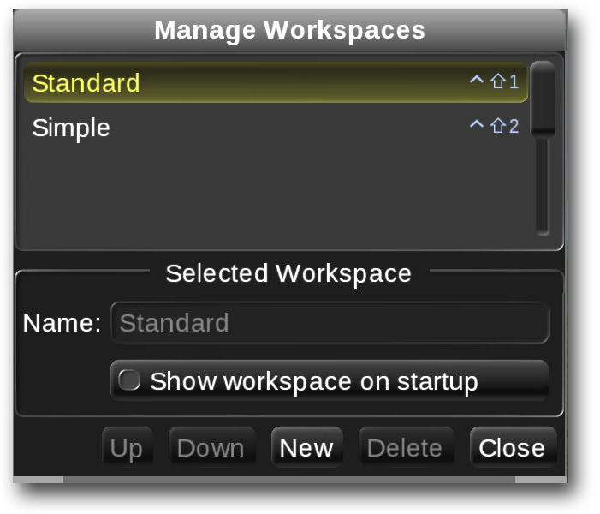

Keyboard shortcut

Edit name field

Enable this button to start Baselight with selected workspace

*Manage Workspaces window*

To change workspaces, select the required workspace from the list, and then click or tap on the **Close** button. Note that the change of workspace is immediate when you select it from the list so you can preview each workspace while this window is open.

Generally, when you start Baselight it displays the workspace that you last viewed. However, to set a specific workspace to be displayed whenever Baselight is launched, select it in the Manage Workspaces window and then select the **Show workspace on startup** option as shown above.

If you start the applcation from the command line, you can use the **-workspace**

argument to specify a workspace to use, for example:

**baselight -workspace Simple**

If you use the -workspace argument but do not specify a workspace, a dialogue box will open asking you to choose one before the application is launched.

To rename a workspace, select it in the Manage Workspaces window and type the new label in the **Name**

field. Note that you cannot rename the factory preset workspaces.

To delete a workspace, select it in the Manage Workspaces window and click on **Delete**.

#### Workspace shortcuts

You can switch workspaces easily using the keyboard shortcut **WIN+[0-9]** (note that the number must be selected on the top row of the keyboard, not the numeric keypad. The factory preset workspaces are assigned

the first few **WIN+n** keyboard shortcuts. User customised workspaces are assigned the next available number when they are created, up to **0**. Any workspaces that are created after this point are not assigned a keyboard shortcut.

To change the assigned keyboard shortcuts, select the workspace in the Manage Workspaces window and click or tap on the **Up** or **Down** buttons to change its position in the list.

If you are working with a Slate or Blackboard control panel, there are dedicated buttons available to switch between workspaces – please refer to the manual for your grading control surface for further details.

## Main Menu and Status Information

#### Main Baselight menu

At the top of every workspace is a menu providing access to most of the system functions and features:



*Main Baselight Menu*

Note that if your workspace is spread across multiple monitors, then the main Baselight menu will appear at the top of the ‘primary’ UI display – this is normally the monitor which provides the login screen when you first start up the Baselight system:

The various menu items provide access to the following:

**Baselight →** System-level functions including user **Preferences** (page 51), **Setups** (page 48) and the **Formats** editor (page 385). This menu also provides and **About Baselight** option which shows details of the currently installed application software and SDKs.

**Scene →** Functions for accessing and saving your work via the **Job Manager** (page 93). This menu also includes the **Clear Undo History** function plus once-click access to a list of recently opened scenes. This list can be cleared from the menu by selecting **Clear Recent Scenes**.

**Edit →** Undo/redo, various copy and paste functions (page 355), stack and strip operations, timeline editing functions (page 252), keyframe options (page 490). This menu also provides functions to enable **Gestural Editing** mode and set the mode of the **Numeric Keypad**.

**Select →** Functions to select strips within the timeline according to various criteria.

**Navigate →** Timeline navigation, zoom and playback controls (page 242) and **Poster Frame** options.

Various bypass modes can also be selected from this menu.

**Marks →** Functions to select and apply marks and categories (page 247).

**Insert →** A list of all operators which can be applied as strips to the grade stack. Note that this menu can be arranged either as a full alphabetic list of items or grouped into separate submenus of related functions using the **Change to Alphabetic/Grouped Insert** option in the menu. Each entry in this menu is described within the relevant section in this user guide.

**Layer →** ‘Compound’ or ‘Macro’ functions which insert a specific type of operator as a layer plus any required matte-generating layers into the stack . This menu also provides control over layer blur plus options to display the layer matte .

**Cursors →** Options to select, create, delete and gang cursors. This menu also provides access to cursor- related functions including **Counters** , **View RGB** channels and the option to

##### Cache All Cursors.

**Display →** Multiple image display layout settings including **Wipe Layout**. Image display options such as

**Bilinear Filtering**, **Display Zoom**, information display and indicator brightness controls .

**Views →** Selecting items from this menu will open floating windows containing controls related to specific areas of functionality – many of these **Views** can also be added to the UI Workspace as ‘docked views’ (see page 60). This menu also provides workspace selection and management options. All the items in this menu will be covered within the relevant chapters of this manual.

**Help →** Access to user documentation and other help resources.

#### Status information area

To the right of the main menu, at the top of the workspace is the status information area. This includes various icons and data indicating the state of various system parameters as described below:

Message log



Queue control

Colour Space Journey hint

Scene lock

Save state

Current scene

Minimise UI

Machine control

Caching indicator

Client View

Audio monitoring

Current time

Working format

*Status information area*

**Message log →** Clicking on this button opens a window showing the most recent warning messages.

There is also an option to open the **Message Log** window .

**Machine control →** This button provides access to the machine control view.

**Caching indicator →** These two icons and three bars indicate the current status of the Baselight caching system – please see The Baselight Cache on page 287 for further details.

**Queue control →** Clicking on this button shows the state of the current operation in the queue. It also allows the operation to be temporarily paused or unpaused as well as providing access to open the **Queue Monitor** window (see page 733). Note that the ‘**Q**’ icon will be orange when the current operation is paused.

**Colour Space Journey Hint →** This button will only appear when there is a message in the Colour Space Journey (CSJ). Click on the button to open the CSJ to find out more (see page 427).

**Client View Status →** The colour of this icon indicates the status of the client view server. Click on the button to check the details and start and stop the service. A client view password can also be set here – see ??? for more details.

**Audio monitoring →** This button provides muting, volume controls and monitoring channel selection for the audio monitoring. Monitor channel mappings can also be edited here (page 645).

**Current time →** Shows the current time of day so you can tell how long it is since you should have gone home.

**Scene lock →** The colour of this icon indicates the lock mode of the current scene – please see page 100 for details.

**Save state →** This icon turns orange when there are unsaved changes in the current scene. If there are no unsaved changes then the icon is white (see ‘uncommitted changes’ on

page 106).

**Current scene →** The current scene name in host:job:scene format. Note that clicking on this button provides a drop-down list of all currently open scenes – select a scene from the list to switch to that scene.

**Working format →** The working format of the current scene is shown in blue after the scene name.

**Minimise UI →** Click on this button to minimise the Baselight UI in order to access other items on your system desktop. Note that you can return to the Baselight application by clicking on its minimised icon in the system dock at the bottom of the screen.

## The Parameters view

The main ‘operational’ area of the graphical user interface is the **Parameters** view (see example above). This part of the workspace contains controls and parameters relating to the currently selected ‘operator’. In Baselight, an operator can be a media source – ie. the input media for a shot – or a processing operator which modifies the image in some way, for example a grading operator or a filter. Other types of operator include matte generators such as shapes and keyers and other special functions such as a reference strip which is

used as a media selector or ‘input switch’ for other operators. Please refer to the Layers & Operators chapter for more information about the different types of operator.

Operators are represented in the Baselight timeline as strips. Note that although Daylight does not provide a timeline, the same operators exist internally and may also be referred to as ‘strips’.

The controls and parameters for the current operator appear in the main panel below the **Strip Details** which are at the top of the Parameters view:

Strip details

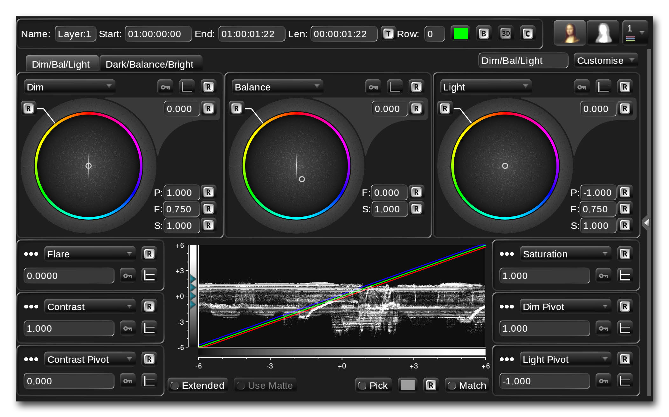

*The Parameters view – stack manager hidden (see below)*

The parameters view provides controls for the currently selected strip in the grade stack, or if the selected strip is an Input Layer or Inside/Outside layer, then it will show details of the operator currently selected in the stack manager panel to the right of the parameter control panel (see below).

In addition to the controls and parameters for the currently selected operator, there are also three other areas or panels which relate to the parameters view as described below.

UI & Workspaces

The Parameters view

The Strip Details panel

#### The Strip Details panel

Details relating to the currently selected strip (operator) are displayed along the top of the Parameters view:

Strip name Timeline start and end timecodes



Strip duration Strip colour

3D strip enable

Row number

Bypass

Strip cache enable

*Strip details panel*

This panel provides details of the strip as shown above. The Name, timecode and Row fields can all be edited by entering data into them directly. Note that if you change the timecode fields, this will change the position and/or length of the strip in the timeline. Changing the row will move the strip to a different position in the grade stack which may affect the overall grade.

The **Bypass** button will toggle the bypass state of the operator (see Bypassing and removing layers on page 303) – note that enabling the bypass button on layer 0 (the ‘Input layer’) will only disable certain operators within the layer, if will not disable the actual input media source.

The other buttons are the 3D strip enable button and the **Strip Cache** (see page 287) – please refer to the appropriate sections of this manual for details of these.

#### The Stack Manager panel

This panel appears to the right of the parameters area. Note that it is only present when an input sequence (‘layer 0’), an Inside/Outside Layer or a matte operator is currently selected. It can be hidden and un-hidden